Department Application
Bronze and Silver Award

ATHENA SWAN BRONZE DEPARTMENT AWARDS
Recognise that in addition to institution-wide policies, the department is working to promote gender equality and to identify and address challenges particular to the department and discipline.

Athena SWAN Silver DEPARTMENT awards
In addition to the future planning required for Bronze department recognition, Silver department awards recognise that the department has taken action in response to previously identified challenges and can demonstrate the impact of the actions implemented.
Note: Not all institutions use the term ‘department’. There are many equivalent academic groupings with different names, sizes and compositions. The definition of a ’department’ can be found in the Athena SWAN awards handbook.

Completing the form
Do not attempt to complete this application form without reading the Athena SWAN AWARDS handbook.
This form should be used for applications for Bronze and Silver department awards.
You should complete each section of the application applicable to the award level you are applying for.

Additional areas for Silver applications are highlighted throughout the form: 5.2, 5.4, 5.5(iv)
If you need to insert a landscape page in your application, please copy and paste the template page at the end of the document, as per the instructions on that page. Please do not insert any section breaks as to do so will disrupt the page numbers.

Word count
The overall word limit for applications are shown in the following table.
There are no specific word limits for the individual sections and you may distribute words over each of the sections as appropriate. At the end of every section, please state how many words you have used in that section.
We have provided the following recommendations as a guide.

Department application | Bronze | Silver
Word limit | 10,500 | 12,000
Recommended word count
1.Letter of endorsement | 500 | 500
2.Description of the department | 500 | 500
3. Self-assessment process | 1,000 | 1,000
4. Picture of the department | 2,000 | 2,000
5. Supporting and advancing women’s careers | 6,000 | 6,500
6. Case studies | n/a | 1,000
7. Further information | 500 | 500

Name of institution | Lancaster University
Department | Languages and Cultures
Focus of department |  | AHSSBL
Date of application | 26 Apr. 19
Award Level | Bronze
Institution Athena SWAN award | Date: 2008, 2010, 2014 | Level: Bronze
Contact for application  Must be based in the department | Dr Emily Spiers | Colette Webb
Email | e.spiers@lancaster.ac.uk | c.webb@lancaster.ac.uk
Telephone | +44 (0)1524 593564 | +44 (0)1524 510738
Departmental website | https://www.lancaster.ac.uk/languages-and-cultures/

Letter of endorsement from the head of department

Recommended word count: Bronze: 500 words | Silver: 500 words

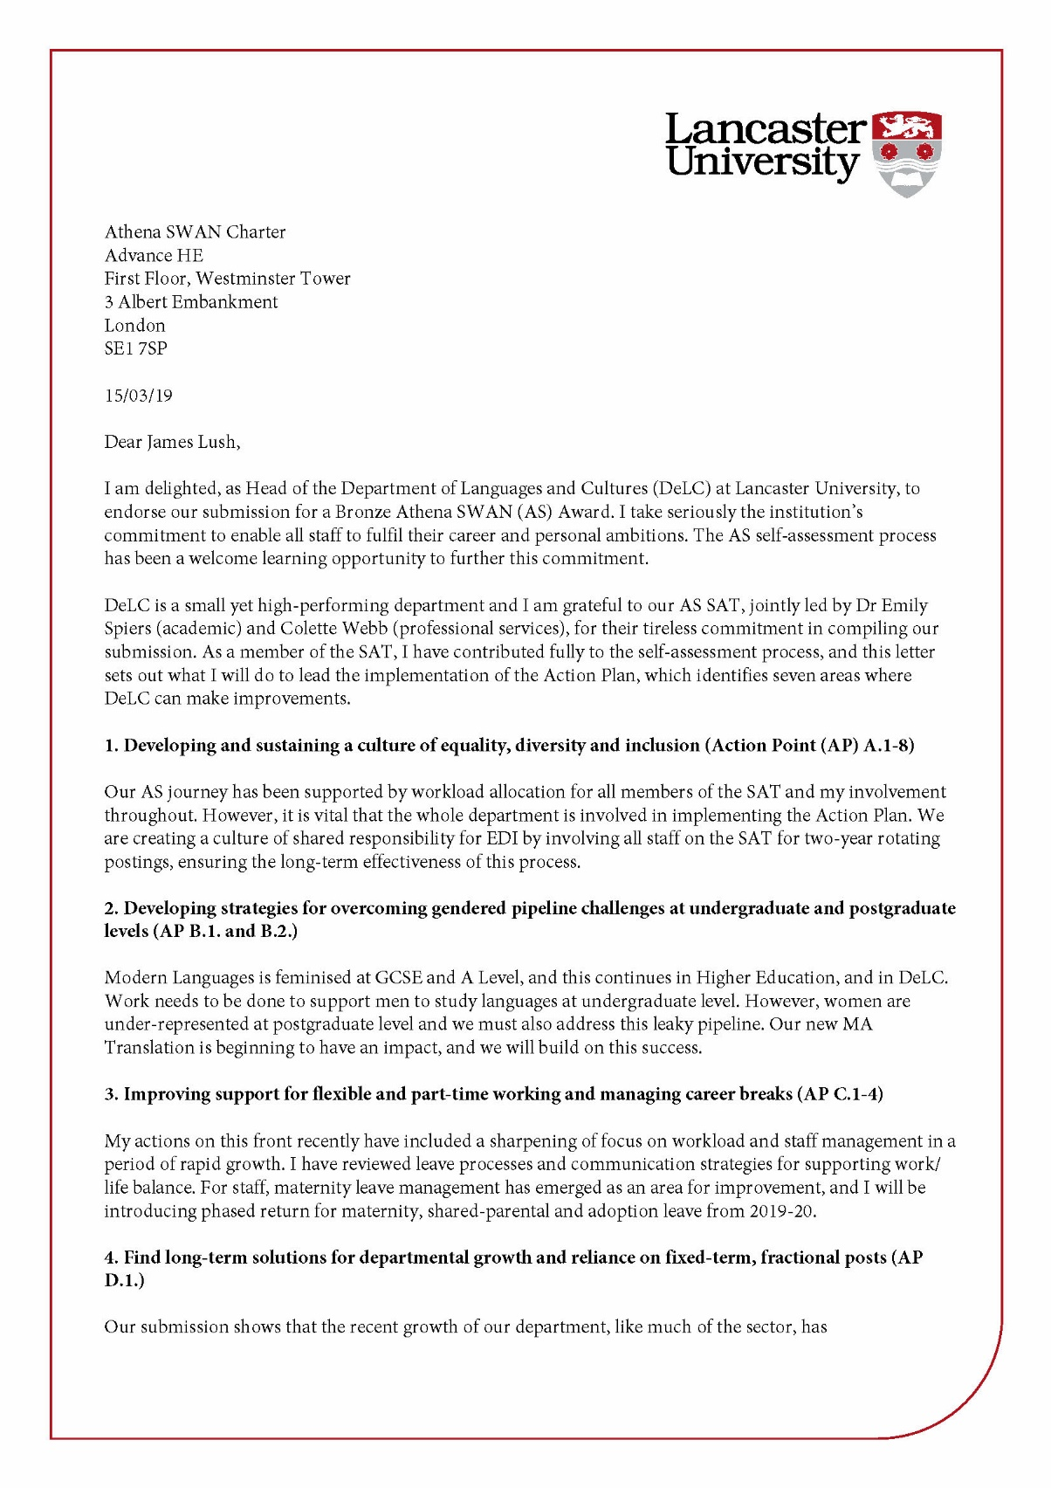

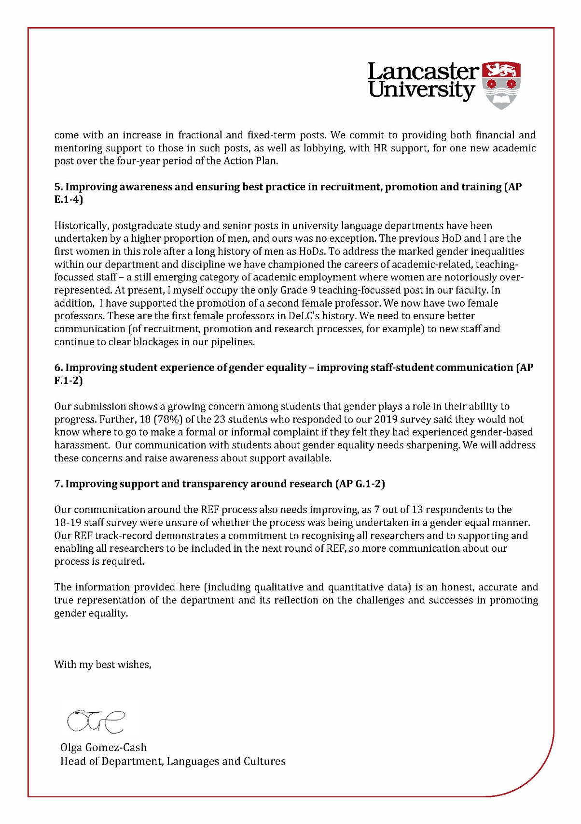

Word count for HoD letter: 803
Overall application word count: 10,475

Glossary of terms and acronyms

- Academic and Teaching Staff – those on contracts that include both research and teaching
- Academic-Related Staff – those without contracted research requirement but who undertake academic leadership and engagement
- AP – Action Point
- AS – Athena SWAN
- CI – Confucius Institute
- DeLC – Department of Languages and Cultures
- DO – Departmental Officer
- ECR – Early Career Researcher
- Faculty – The Faculty of Arts and Social Sciences
- FTC – Fixed-Term Contract
- F/T – Full-Time
- Focus Group –invitation to all UG/PGT and PGR students to attend focus group in summer term 2018 run by SAT Chair
- Grade category A (Lancaster University uses A for Academic Staff)
- Grade category P (Lancaster University uses P for Academic-related and Professional Services Staff)
- HoD – Head of Department
- IC – Indefinite Contract
- ISF – Institute for Social Futures
- LangCom – Language Committee
- LU – Lancaster University
- Moodle – LU’s online learning platform for students
- OED - Organisation and Educational Development (Institutional-Level Unit)
- PDR - Performance Development Review
- PGCAP – Postgraduate Certificate of Academic Practice
- PGR – Postgraduate Research
- PGT – Postgraduate Taught
- PS – Professional Services Staff
- ProVC – Pro-Vice Chancellor
- ResCom – Research Committee
- SAT – Athena SWAN Self-Assessment Team
- SMT – Senior Management Team
- Survey – staff and student online surveys carried out by SAT in 2018 and 2019. Distributed to all staff and all students via email link with explanatory email
- Teaching-Only Staff – those paid hourly for teaching otherwise referred to as Associate Lecturers
- TeaCom – Teaching Committee
- UG – Undergraduate
- UCML – University Council of Modern Languages
- VC – Vice Chancellor

Description of the department

Recommended word count: Bronze: 500 words | Silver: 500 words
Lancaster University’s Department of Languages and Cultures (DeLC) delivers 26 UG and PG degree schemes and provides a lively environment for research and study. All DeLC major subjects are placed in the top 2 of the Times and Sunday Times Good University Guide 2019: German 1st, French 2nd, Spanish 2nd.
The department is small enough to allow students and staff to work closely together.
Figure 1 is a photo of the department social space during Welcome Week 2018.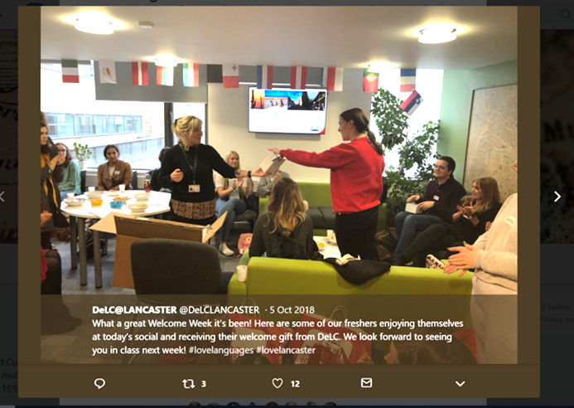

Figure 2 shows that, befitting a department of languages and cultures, DeLC staff represent a variety of nationalities and cultures.

DeLC is one of nine departments in the Faculty of Arts and Social Sciences (FASS) (Figures 3 and 4).

Figure 3: Department of Languages and Cultures within Lancaster University
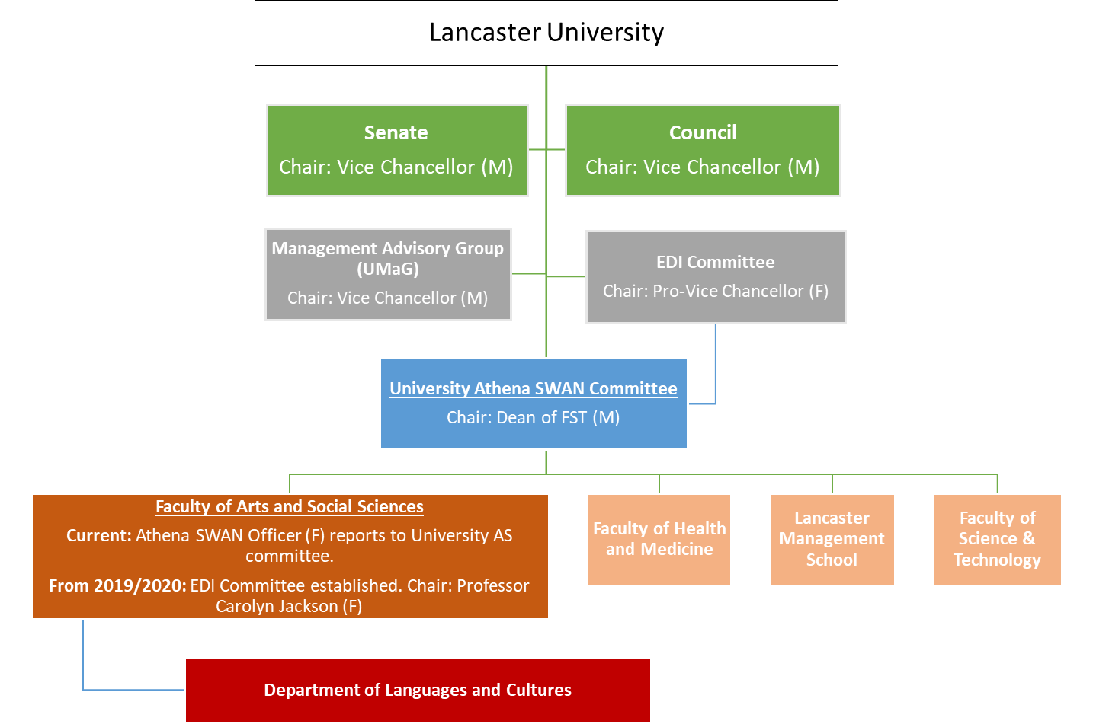
Figure 4: shows the structure of the department, its affiliation with the Confucius Institute and reporting within FASS:
From 2019 onwards, it will be written into every Director and Officer’s role that they have a part to play in the delivery of the Action Plan (AP A.1.).
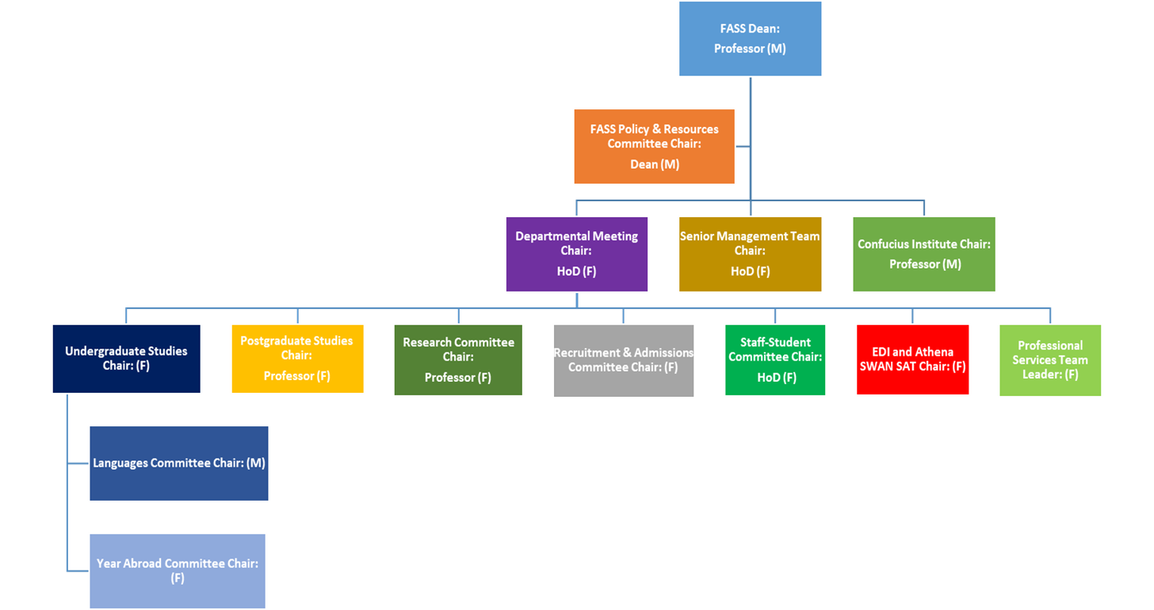

Our Departmental Officer convenes team meetings of professional services staff. This was a practice set up by the new HoD and initially convened by herself, until a permanent DO was appointed. The HoD is supported by a Senior Management Team comprising 4 women and 2 men, who meet termly. The SMT provides preparatory experience for future HoDs.
Table 1: DeLC’s Senior Management Team
Female, academic-related, HoD, grade 9P¹
Female, academic, grade 9A²
Female, academic, Professor
Female, academic, Professor
Male, academic, grade 9A
Male, academic, grade 9A
Female, professional, DO, 6P

We are currently experiencing rapid growth in student and staff numbers.
In 2016-17, DeLC joined forces with the Confucius Institute (CI) to incorporate Chinese-language teaching into its curriculum. We share 1 academic (male) and 1 academic-related (female) staff, who lead and deliver the Chinese undergraduate and elements of postgraduate programmes. In addition, in 2017/8, the department made 4 academic appointments, 3 M, 1 F and 2 female PS appointments.
In 2018/19, the number of first year students enrolled on a DeLC part one module increased from 317 to 390 students, which is just over 1 in 10 of all first-year students enrolled at LU.

We convene and deliver 22 UG degrees and co-deliver a further 6. We convene and deliver 4 PG degrees.
Table 2: UG degree schemes delivered/co-delivered by DeLC
Single Honours:  - BA (Hons) French Studies  - BA (Hons) German Studies  - BA (Hons) Spanish Studies  - BA (Hons) French Studies with minor in Chinese  - BA (Hons) French Studies with minor in Italian  - BA (Hons) German Studies with minor in Chinese  - BA (Hons) German Studies with minor in Italian  - BA (Hons) Spanish Studies with minor in Chinese  - BA (Hons) Spanish Studies with minor in Italian. | Joint Honours:  - BA (Hons) French Studies and German Studies  - BA (Hons) French Studies and Spanish Studies  - BA (Hons) German Studies and Spanish Studies  - BA (Hons) Modern Languages (French, German and Spanish)  - MLang Languages and Cultures
Joint Honours with other departments (DeLC convenes and delivers)  - BSc (Hons) French Studies or German Studies or Spanish Studies and Computing  - BA (Hons) French Studies or German Studies or Spanish Studies and English Literature  - BA (Hons) French Studies or German Studies or Spanish Studies and Film  - BA (Hons) French Studies or German Studies or Spanish Studies and History  - BA (Hons) French Studies or German Studies or Spanish Studies and Linguistics  - BA (Hons) French Studies or German Studies or Spanish Studies and Mathematics  - BA (Hons) French Studies or German Studies or Spanish Studies and Philosophy  - BA (Hons) French Studies or German Studies or Spanish Studies and Politics  - BA (Hons) French Studies or German Studies or Spanish Studies and Psychology  - BA (Hons) French Studies or German Studies or Spanish Studies and Theatre | Joint Honours with other departments (DeLC co-delivers and other department convenes)  - BA (Hons) French Studies and Criminology  - BA (Hons) English Language and French Studies or German Studies or Spanish Studies  - BA (Hons) French Studies or German Studies or Spanish Studies and Geography  - BA (Hons) Management Studies and European Languages
DeLC PG degrees
- MA in Translation
- MA in Languages and Cultures
- European Languages and Cultures PhD/MPhil
- Translation PhD/MPhil

As of June 2018, the total number of students taking degrees convened by the department is 195, of whom 160 are UG and 35 PG. We have a majority of female students, in keeping with the discipline of Modern Languages at secondary school level and HESA statistics for Modern Languages (see 4.1).

Table 3: shows DeLC has a majority of female students across all levels of study, 2017-2018.
 | Female |  | Male
Level of study | Number | % | Number | % | Total
Undergraduate | 115 | 72 | 45 | 28 | 160
PGT | 16 | 73 | 6 | 26 | 22
PGR | 7 | 54 | 6 | 46 | 13
Total | 138 | 71 | 57 | 29 | 195

DeLC is committed to improving the uptake of male undergraduates (AP B.1.). However, figures reveal that PGR numbers are proportionately 6% of undergraduate numbers in the same year for women but 13% for men. This indicator of a pipeline issue is being addressed (AP B.2.).
Table 4 shows that in 2017-2018, DeLC had 22 academic staff in total, with a gender split of 18 (82%) women to 4 (8%) men, and that we had no male professors. That women staff are in the majority is a recent development in the department’s history (see HoD’s Letter of Endorsement and section 4.2).
Table 4: Academic staff for the period August 2017 to July 2018, by gender and grade. DeLC has a majority of female staff.

Gender | Gr6 | % | Gr7 | % | Gr8 | % | Gr9 | % | Prof | % | Total | %
F | 3 | 74 | 5 | 83 | 5 | 86 | 3 | 75 | 2 | 96 | 18 | 82
M | 1 | 26 | 1 | 17 | 1 | 14 | 1 | 25 | 0 | 4 | 4 | 8
 |  |  |  |  |  |  |  |  |  |  | 22

In this submission we report on three years of data 2015-2018. However, we note that here that, as of 2018-19, the department has a total of 44 staff, 32 (73%) women and 12 (27%) men). Of these, 6 are professional services staff.

Table 5: shows significant staff increase in 2018-19, especially in Associate Lecturers. The variety of roles, contracts and FTE shows the scale of the growth.
Role | Male | % |  |  | Female | % | Total
Academic staff | 3 | 30 |  |  | 7 | 70 | 10
 | 3 x 1FTE (IC) |  |  |  | 7 x 1 FTE (IC)
Academic (teaching-focussed) staff | 4 | 29 |  |  | 10 | 71 | 14
 | 2 x 1 FTE (IC)  1 x 0.7 FTE (FTC)  1 x 0.5 FTE (FTC) |  |  |  | 3 x 1 FTE (2 x IC, 1 x FTC)  1 x 0.7 FTE (IC)  3 x 0.6 FTE (1 x IC, 2 x FTC)  3 x 0.5 FTE (1 x IC, 2 x FTC)
Associate Lecturers | 4 | 29 |  |  | 10 | 71 | 14

We have unusually called on the support of 14 Associate Lecturers, who are employed on a part-time, teaching-only basis, to help in this year of sudden growth of student numbers. Associate Lecturers are hourly-paid, not fractional. There can be no FTE calculation because some Associate Lecturers have delivered 12 lectures, some have delivered 80 hours of teaching.

Qualitative research undertaken by the SAT through staff and student online surveys (2018/2019) and student focus group (2018) demonstrates that staff and students largely consider DeLC to offer a positive and gender-balanced working environment. One respondent to the DeLC 2019 staff survey said:
‘DeLC does very well at creating a climate of fairness and equality.’ (female, academic)
One respondent to the DeLC 2019 student survey reported:
‘The culture within DeLC is one of community, we look after each other and try the hardest not to exclude anyone from any activity.’ (female, postgraduate)
100% (26 out of 26) respondents in the 2019 student survey felt that students in DeLC were treated equally, regardless of their gender.
627 words
Actions from this section
Action plan number | Action
AP A.1. | Delivery of Athena SWAN Action Plan written into every Director’s role
AP B.1. | Improving the uptake of male undergraduates
AP B.2. | Improving leaky pipeline of females from UG to PGT & PGR

The self-assessment process

Recommended word count: Bronze: 1000 words | Silver: 1000 words

a description of the self-assessment team:
The HoD initiated Athena SWAN work in the department in November 2017. The HoD, who has the best overview of the work allocation plan, approached Colette Webb and Emily Spiers (who has a research background in gender studies) to co-chair the SAT. In consultation with the Co-Chairs, the HoD approached other colleagues to assemble a team with a cross-section of roles in the department. The SAT’s work is factored into members’ workloads with points, as with other administrative roles in the department.

Table 6: The membership of DeLC’s SAT
SAT Member | Gender | Departmental Role and relevant experience | SAT Role
Emily Spiers | Female | Academic staff: Lecturer (Early Career Researcher) | Co-Chair; Student working group (student surveys and focus group)
Colette Webb | Female | Professional Services-Staff: Confucius Institute Manager;  Shared caring responsibilities for elderly parents. | Co-Chair; Staff working group (Management equality practices)
Olga Gomez-Cash | Female | Academic-related staff: Head of Department; Shared caring responsibilities for elderly parent and sibling with acute mental health challenges. | Staff working group (Working practices; role models, participation, leadership)
Sarah Elliott | Female | Professional Services staff: Departmental Officer | Staff working group (Working practices and departmental culture)
Thomas Martin | Male | Associate Lecturer; Works part-time | Staff working group (Access and progression)
Amit Thakkar | Male | Senior Lecturer; caring responsibilities | Student working group
Aiqing Wang | Female | Senior Teaching Associate; Department Equality, Diversity and Inclusion (EDI) Lead | Staff working group (Management equality practices)

DeLC has two professors (F), both of whom were on sabbatical for significant periods of 2018, so we were unable to include them. We have instead included one Senior Lecturer, and the HoD who has a long-standing commitment to gender equality in DeLC.
Figure 5: Shows equity of role representation across the SAT. The numbers represent the number of members holding that role.

Figure 6: shows variety of length of service in SAT members. The numbers represent the number of members of that length of service.

Presently across LU, Professional Services staff do not have workload allocation, although this has been raised as an issue by the HoD. Our DO was included in the SAT as having an overview of staff HR matters is part of her role, and she was new in post in 2017. Thus, supporting the submission was intended to support her developmentally.
We also included one staff member on a short-term, part-time contract. DeLC has arranged to pay him for his Athena SWAN work when he is not teaching for the department. We also included two members who represented staff with significant work-life balance arrangements/caring responsibilities. We debated whether we needed to include more men on the SAT, but felt that the distribution as it stood echoed the gender balance of the department and was thus representative.

an account of the self-assessment process
Athena SWAN has been a regular item on the departmental meeting agenda since the start of 2018. The involvement of the HoD in the SAT’s work right from the start has meant that the Co-Chairs are able to report directly to her and that the Athena SWAN agenda is represented in any major decisions made within the department. The department’s EDI lead has been a SAT member since inception, meaning that the department has incorporated the Athena SWAN process into its broader EDI work.
The SAT has met every other month since December 2017, with a gap over the summer break 2017-18. At time of writing, we have met ten times overall. The group communicates via email, face-to-face in meetings and one-to-ones and via a shared secure online data-storing platform. Table 7 (overleaf) gives details of the process.

Table 7: DeLC’s SAT Process
Date | Action | Detail
10/2017 | SAT formed | Potential candidates approached.
18/12/2017 | First SAT meeting | Understanding Athena SWAN process and its history institutionally.  Brainstorming current culture of gender equality in the department.  Working groups formed for independent work.
The working groups were:
(i) Working practices and departmental culture –Sarah Elliott and Colette Webb
ii) Access and progression (who has access, applications to posts, what types of contract, who is progressing)-Tom Martin, Olga Gomez-Cash
iii) Management equality practices –Aiqing Wang and Colette Webb
(iv) Broadening engagement and social responsibility –Amit Thakkar and Colette Webb (role models, participation, leadership).
(v) UG, PGT and PGR student experiences; gender balance in the classroom; focus group – Emily Spiers
25/01/2018 | SAT meeting | Planned staff surveys.  Spiers reported on sector-wide research undertaken for bench-marking purposes.
06/02/2018 | SAT meeting | Signed off on survey  Developed strategy for highlighting the survey and encouraging a high response e.g. posters around the department; reminder emails; chocolates in the Post Room next to the reminder poster.
16/04/2018 | SAT meeting | Analysed survey data and began Action Plan  Meeting attended by Faculty Athena SWAN Officer Brigit McWade, who advised on next steps and alerted us to new institutional support in terms of data provision  Co-Chairs organised training for the SAT with colleagues in HR and Information Services to help them with quantitative data and the various platforms they needed.
11/05/2018 | SAT meeting | Student survey design  Strategies for maximising responses.  Planned student focus group; organised pizza and confectionary.
16/10/2018 | SAT meeting | Analysed results of student survey and focus group  Began drafting application form.
30/10/2018  14/11/2018  26/11/2018  26/11/2018  22/01/2019 | SAT meeting | Trouble-shooting application work
22 January 2019 | SAT meeting | As above

We have run two online staff surveys (in 2018 and 2019) and two online student surveys (in 2018 and 2019). The 2018 staff survey response rate was 20 responses out of 44 staff members. In 2019, we disaggregated the surveys: for academic and academic-related staff the response rate was 15 out of 38 staff members; for Professional Services staff the response rate was 5 out of 6 staff members. In 2018, the student (UG and PG) response rate was 14 out of 195 students; in 2019, the rate was 24 out of 195 students.
Despite reminders, posters around the department and chocolates in the Post Room, uptake for all surveys was low. We need to address this by reconsidering our promotional strategy and sending survey email in vacation times rather than term times. (AP A.1.)
As no students committed to joining the SAT, we ran a dedicated student focus group in summer term 2018. Six undergraduates, all female, attended. The focus group was open to PGT and PGR students, but none were able to attend. Our PGT and PGR cohort is relatively small. We will seek to recruit students to participate (paid) in the SAT for the future. Faculty Athena SWAN Officer, Dr Brigit McWade, supported the application as a critical friend. She conducted external consultation on behalf of all the departments in the Faculty. The Co-Chairs both attended the institutional Athena SWAN forum that runs termly, to network with other departments and glean best practice. Two Athena SWAN trained panellists reviewed our application: Professor Chris Harris and Dr David Peet.

plans for the future of the self-assessment team
The SAT will continue meeting and working towards the successful implementation of the areas identified for action in the Action Plan. It will meet twice a term, once at the beginning to set a termly agenda and once at the end to track progress and set work for non-term time. Focus of the meetings will be on implementing the action plan and forward plan for future EDI work.
Work of the SAT will be communicated as: a standing item on the Departmental Meeting agenda; SAT members will report to staff-student committees (AP F.1.); and, gender equality issues/opportunities via posters around the department (AP A.2; AP F.1.).
To create a culture of shared responsibility for EDI, all staff will be expected to rotate to participate on the SAT for two-year postings at some stage of their working life with DeLC. Athena SWAN SAT work will be in workload allocation as a major administrative role (AP A.1.). We consider it a priority to have student representation on the SAT and will seek UG and PG representation in October 2019 (AP. A.1.).
841 words

Actions from this section
Action plan number | Action
AP A.2. | Athena SWAN SAT combining forces with the EDI Officer (underway)
AP A.1. | All staff will be expected to rotate to participate on the SAT for two-year postings at some stage of their working life with DeLC.
AP A.1. | Improve uptake for all surveys was low. We need to address this by reconsidering our promotional strategy and also the timing of the survey. Increase staff and student survey responses which will demonstrate greater departmental ownership.
AP F.1. | SAT members and EDI Officer will attend staff-student committees
AP A.2.; AP F.1. | Keep staff and students up to date on gender equality issues/opportunities via posters around the department.

4. A picture of the department

Recommended word count: Bronze: 2000 words | Silver: 2000 words

4.1 Student data
If courses in the categories below do not exist, please enter n/a.
Note about data: we include data on academic year 2018-19 where it is meaningful, i.e. data is not complete in terms of attainment, but it is in terms of registration.

Numbers of men and women on access or foundation courses

N/A

(ii) Numbers of undergraduate students by gender
Data from the British Council and the Joint Council for Qualifications show that the languages sector is already feminised from GCSE level onwards, with 56% of girls taking a language. At A-level this ratio increases to 63%F.

Figure 7: A-level candidates by gender.

Our data shows that at undergraduate level our gender ratio continues this trend - Figure 8 shows we have a majority of female students. It also matches that of the Higher Education sector for Modern Languages, which is 72% female / 28% male at undergraduate level.
Figure 8: Number and % of undergraduates studying languages in DeLC by gender alongside HESA statistics from 2017-18

Figure 9 shows that acceptances and registrations by male undergraduates dropped by 10% in 2016-17 and 2018-19. We need to improve the pipeline for potential male undergraduates interested in studying at DeLC, providing more male role models in outreach and engagement events at Secondary school level (AP B.1.). One option is to run a tailored recruitment event like that undertaken by Edinburgh Napier University to recruit more men into nursing (AP B.1.).
Figure 9: shows application, offers and acceptances of undergraduates by gender.

Figure 10 shows undergraduate degree attainment by gender. First-class degrees have increased for women and decreased for men. The opposite is true for lower-second class honours (AP B.3).

(iii) Numbers of men and women on postgraduate taught degrees
Figure 11 shows postgraduate taught students, full- and part-time alongside HESA statistics for Modern Languages 2017-18. DeLC’s data
shows general correspondence with national gender ratios at PGT level, although in 2016-17 we attained near full gender parity.

Figure 12 shows that these male to female proportions remain broadly consistent across the process of student application, offers made, acceptances and registrations at PGT level.

Between 2013/2014 – 2017/2018, DeLC awarded 15 PGT degrees. We have combined the data for these years as numbers are small.
Figure 13 shows male to female proportions of attainment and Figure 14 shows ratio of attainment within gender for all these years combined as numbers are small.

These show that men are less likely to gain a distinction. As numbers are small and over a long time period, this requires further monitoring and tailored actions to address if the pattern persists (see AP B.3.).

(iv) Numbers of men and women on postgraduate research degrees
Figure 15 shows that we achieve near full gender parity at PGR level, and that historically more men PGRs study part-time. Nationally, enrolments at PGR were 63% female (2017-18), which we do not meet (AP B.2).
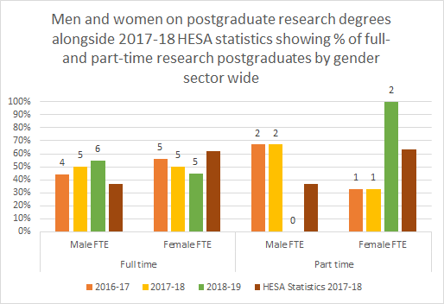
The part-time male PGRS in DeLC were either from the local community or members of academic-related DeLC staff, studying alongside their day jobs.

Figure 16 shows that while applications from female students for PGR have risen, the number of acceptances has not achieved the same growth.

Whilst the cohorts are relatively small, the Department is concerned that such trends might continue and establish themselves as it expands its appeal to postgraduate students especially as the progression pipeline is indicative of similar tendencies. (AP B.2.)
Historically DeLC’s PGR numbers have been low, including many periods without any PGRs. We have only awarded 3 PhDs in the reporting period, 1M and 2F. We will put in place mechanisms to monitor attainment going forward.

(v) Progression pipeline between undergraduate and postgraduate student levels
Our data shows that we achieve near gender parity at PGR level. However, given the pronounced gender ratio in favour of females at UG and PGT levels, this suggests we have a leaky pipeline with the proportion female students decreasing from PGT and PGR levels. Notably, in the reported period, the proportion of female PGT has grown by almost 20%.

The Department will consider various measures to address this disparity with a view to improving rates of acceptance from external female applicants for PGR as well as improved rates of application and acceptance from our existing UG students. We will ask female PGR students to take a lead role in recruitment activities such as talks, tours and online publicity material (AP B.2.). DeLC will also conduct a survey of PGR students to investigate motives and concerns of our existing cohort and analyse results based on gender (AP B.2.).
416 words

Actions from this section
Action plan number | Action
AP B.1. | Improve the pipeline for potential male undergraduates interested in studying at DeLC and also provide more male role models in outreach and engagement events at Secondary school level; highlight male role models at our Open Days and Applicant Visitor Days; run dedicated recruitment day for potential male UG candidates
AP B.3 | Improve degree attainment at UG and PGT level for male students and monitor degree attainment for women at PGR
AP B.2. | Improve the PG pipeline for women by 1) asking female PGR students to take a lead role in recruitment activities such as talks, tours and online publicity material 2) Conduct a survey of PGR students to investigate motives and concerns of our existing cohort and analyse results based on gender

4.2 Academic and research staff data
- Academic staff by grade, contract function and gender: research-only, teaching and research or teaching-only
N.B. Data presented in this section draws on an average of monthly snapshots taken over a year, from August-to-July. For guidance, Table 8 maps the university grades to HESA levels.
N.B. We are including reports on the current year, which is incomplete, given significant changes to staff numbers and gender balance.
Table 8: LU grades description and corresponding HESA levels

Grade | Description | HESA level
5S | Grade 5 Support Staff | N0
6A/6S | Grade 6 Academic & Support Staff | L0
7A | Grade 7 Academic Staff | K0
8A | Grade 8 Academic Staff | J0
8P | Grade 8 Professional Staff | J0
9A | Grade 9 Academic Staff | I0
AC04 | Professorial | F1

Figure 17 shows DeLC academic staff are in the majority women.

As of 2018-19 we have 27 women (71%) and 11 men (29%), just exceeding the national HESA benchmark of 66% women. We currently have no male professors. However, this is a very new development in the history of DeLC, where professors were exclusively men (until 2003) and where HoDs were generally also men (though not always in professorial roles).

In DeLC’s case, the pronounced ratio of women to men is the result of a rapid decrease in staff numbers between 2000 and 2010 and the retirement of many of the founding members of staff of the department, who were predominantly male. In recent years, the department has predominantly recruited early-career academic women who have been able to grow their careers at Lancaster. One member of staff was recruited in 2010 as a Junior Lecturer and is as of 2017 DeLC’s latest female Professor (one of 2). Since 2018, DeLC has recruited a number of male colleagues in both academic-related and teaching and research roles, which is improving gender parity.
For comparison, Modern Languages at Durham University, our closest competitor, has a gender ratio of 56% (88) female staff to 44% (69) male. However, they have 19 Professors, only 4 (21%) of which are female. The School Manager is the only PS staff who is male, and the majority of teaching-only staff are female (80%).

Figure 18 shows that in the previous 3 years, the proportion of men on grade 9 academic contracts is higher than the proportion of male staff across the whole department.

Figure 19 shows that academic-related and teaching-only roles are held predominantly by women. There is one man at grade 6 and one man on grade 7 in academic-related roles, whilst women on these contracts predominate at grades 8 and above.

At grades 7 and 8, the proportion of women to men roughly matches that of the department overall.

However, recent recruitment of male staff has reduced the proportion of women to men in the department from 18 women (82%) / 4 (8%) men in 2017-18 to 27 women (71%) / 11 men (29%) in 2018-19. New staff data from 2018-19 shows that we now have 2 men at grade 9 which also suggests a developing pipeline from grade 9 to Professorial for male academic staff.

Since September 2018, the department has recruited 1 male Lecturer at grade 7, 2 more male academic-related members of staff at grade 7, as well as 4 more male teaching-only Associate Lecturers. This has created a more equitable gender balance for academic-related and teaching-only staff in the department and increased male role models for students.

Only one Research Only contract was held in the reported period, 1F in 2015/2016.

Figure 20: shows that the number of academic staff on a fractional contract has increased for women in the reported period, in the main because posts covering the secondments of senior staff to Head of Department, Associate Dean in the Faculty, Co-Director of the ISF and research/sabbatical leave were fractional posts.

We have a job-share arrangement in one of the language sections (2 academic-related staff, female). In raw numbers, half of all the women in the department are now part-time. All of the 10 current academic staff are full-time.
To insert a landscape page, please copy from here down to the next red marker and paste into the document where the landscape page is required.

Figure 21 shows DeLC progression pipeline for women from UG to Professor 2016-17. Leaky pipeline for women apparent at PGT, PGR and RA levels
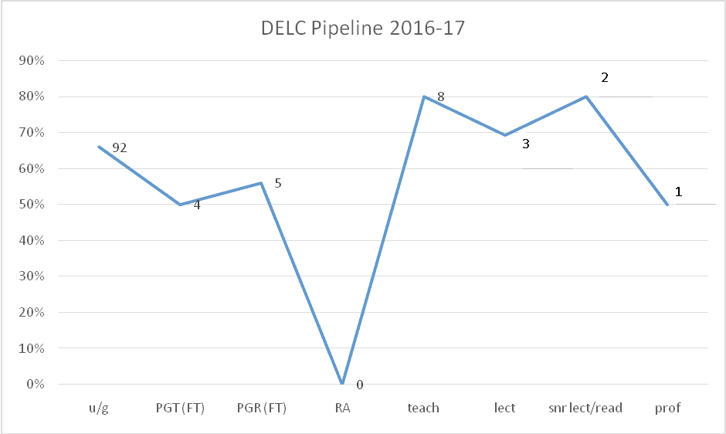

Figure 22: shows progression pipeline for women from UG to Professor 2017-18. New MA in Translation addressing leaky pipeline for women at PGT. However, pipeline leaks again at PGR and RA levels.

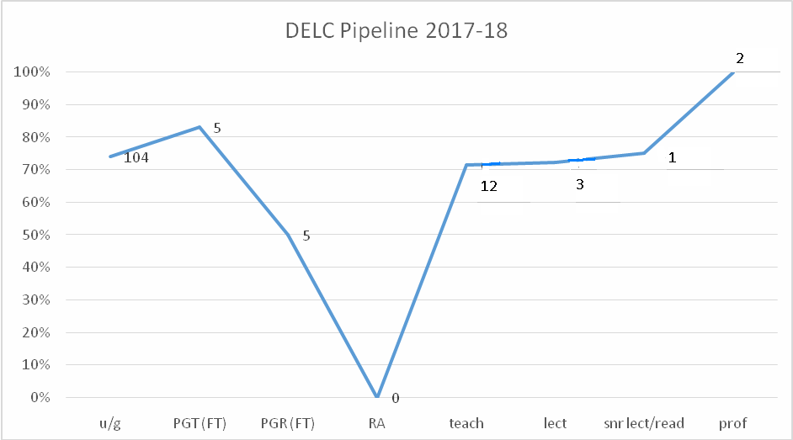

Our intention is to focus on improving the pipeline of male undergraduates (AP B.1.) in order to take a longitudinal approach to improving gender parity of staff in the DeLC and the languages sector more generally. Our intention is not to disadvantage women in the process nor undo the work that has been done to address gender inequalities, as they were historically, in the opposite direction.

ii) Academic and research staff by grade on fixed-term, open-ended/permanent and zero-hour contracts by gender
Figure 23 shows there has been a significant increase in the number of women on fixed-term contracts within the department over the last 3 years (academic and research staff on FTC and IC).

Table 9 shows that whilst the number of women and men on indefinite contracts has remained steady, there has been a significant increase in the number of women on fixed-term contracts within the department over the last 3 years, from 1 to 4.

 |  | Indefinite |  |  | FTC
Year | Grade | F | M | %F of all IC | F | M | %F of all FTC
2015/16 | 10 | 1 |  | 76% |  |  | 50%
 | 9 | 4 | 2
 | 8 | 1 | 1
 | 7 | 6 | 1
 | 6 | 1 |  |  | 1 | 1
 | Total | 13 | 4 |  | 1 | 1
2016/17 | 10 | 1 | 1 | 78% |  |  | 67%
 | 9 | 4 | 1
 | 8 | 3 | 1
 | 7 | 5 | 1 |  | 1
 | 6 | 1 |  |  | 1 | 1
 | Total | 14 | 4 |  | 2 | 1
2017/18 | 10 | 2 |  | 82% |  |  | 80%
 | 9 | 3 | 1
 | 8 | 5 | 1
 | 7 | 3 | 1 |  | 2
 | 6 | 1 |  |  | 2 | 1
 | Total | 14 | 3 |  | 4 | 1

DeLC is a small department experiencing a period of growth and increasing complexity as evidenced by the new committees mentioned in section 5.6(iii). A spike in the number of undergraduates signing up to take a language in First Year, as occurred in 2018-19, has meant that the Department had to respond rapidly to ensure teaching was covered. This led to the HoD drawing in fixed-term, part-time Associate Lecturers in the first instance. We see these posts as developmental for junior academics whom we actively support to go on to use that experience to secure indefinite contracts at other institutions (see section 5.3.iii). Nevertheless, in recognition that such contracts are not secure, DeLC plans to adjust to growth and limit numbers of Associate Lecturers next year by applying to create a new post and working with HR about improving employment practices in DeLC (AP D.1.). This shows that we are acting on the sector-wide over-reliance on fractional and fixed-term contracts and bolstering those in these roles where we can.
The employment of FTC staff to cover staff away on sick leave or research leave is one strategy used by the Department to avoid creating ‘invisible work’ for staff by redistributing the workload of the absent colleague across the department. Two fractional and fixed-term posts have been created to cover two members of staff (both grade 9) as they take on leadership roles (HOD, Faculty Associate Dean), while an additional one covers for a member of staff who had been successful in securing external research funding.
One academic-related member of staff (female, fractional 0.5) is on sick leave and instead of redistributing her workload across the department the HoD employed a fixed-term academic-related member of staff to cover her leave. Another example includes the long-term sick leave of one female professional services staff member, whose absence was covered by a series of intermittent fixed-term contracts. Once it became clear that the member of staff on sick leave would not be returning, the position was re-configured and advertised. The person (female) covering the role on an FTC was encouraged to apply and secured the permanent role. Further, the HoD succeeded in expanding 2 fractional contracts (fixed term) in 2018 (two 0.5 posts became 0.7 (grade 6, 1 M, 1F), and one grade 6 0.5 FTE was made grade 7 FTE).

(iii) Academic leavers by grade and gender and full/part-time status
Lancaster University does not currently collect data on the reasons for academic staff leave. However, this will commence in the next academic year as part of the institutional Athena SWAN action plan. DeLC will also collect data to identify whether there are gendered reasons for staff leaving (AP A.7.).
Reasons for academic staff leaving (apart from end to FTCs):
2015/6: N/A
2016/7: 1 Retirement (grade 9, male, academic, full time)
1 Resignation to move on to higher grade post in UK HE (grade 6, male, academic related, fractional)
2017/8: 1 Retirement (grade 9, female, academic related, full time)
2018/9: 1 Resignation to move on to higher grade post in UK HE (grade 7, female, academic related, full time)
1242 words

Actions from this section
Action plan number | Action
AP C.3. | Increase awareness of equal opportunities for fractional and part-time staff
AP D.1. | Adjust to growth and limit numbers of Associate Lecturers next year by applying to create a new post
AP A.7. | Collect data on academic leavers in order to identify whether there are gendered reasons for staff leaving

5. Supporting and advancing women’s careers

Recommended word count: Bronze: 6000 words | Silver: 6500 words

5.1. Key career transition points: academic staff

Recruitment
The Department follows the University’s and Faculty’s Recruitment and Selection Policy and Guidance for appointing new staff. The Department has stated ‘We welcome applications from people in all diversity groups’ in all recent adverts.
LU has recently issued a ‘Recruitment Toolkit’ to sit alongside the Recruitment and Section Guidance Documents to support best practice from identifying a vacancy to making an appointment. This includes a new software tool, through which proposed job adverts can be run to identify any gender bias and make any changes needed.
The University sets panel composition guidelines according to grade of post. Posts up to grade 6 are chaired within the Department, grade 7 upwards by the Faculty Dean’s group / ProVC / VC. Panel chairs must undertake the University’s ‘Recruiting the Best’ training and all panel members must undertake diversity training. The department supports diversity on shortlisting and interview panels ensuring a balance of gender and experience. Links to ‘Understanding Unconscious Bias’ are provided on the University’s EDI pages. AP A.2 references the EDI workshop with emphasis on Unconscious bias which we will run for all DeLC staff.
Recruitment channels include: jobs.ac.uk; indeed.co.uk; UCML and language/subject-specific JISCmail email lists.
In 2015/16, 2 named appointments were made (both women to grade 6P and 7P posts). The data for the posts since 2016/17 shows more women than men at application, interview and appointment for all the posts during this period with the gender ratio equal for the grade 7P post in 2017/18.

Figure 24: Shows Recruitment Data (2016/17 – 2017/18). There was an increase in applications from men for grade 6 and 7 roles.

The data suggests that between 2016-17 and 2017-18, there was an increase in applications from men for grade 6 and 7 roles.
Central recruitment data for 2018/19 is not yet complete. However, recent appointments in the department have resulted in: 1 male to a 9A post; 1 male to a 7A post; 1 female and 1 male to two 7P posts. This has increased the number of male staff overall in the Department.
One new member of staff described the DeLC recruitment process as follows:
‘My DeLC recruitment process included two stages. The first activity was a presentation on a proposed module and a question and answer session with DeLC staff, most of whom were women. The second activity was a more formal interview with a panel of five staff, three of whom were women, although the two most senior figures (PVC and Dean) were men. At all stages I was treated with great courtesy and provided with assistance where needed; I got a sense of LU staff and certainly DeLC staff as very friendly.’ (male, unspecified role)
Another commented:
‘On the day of the interviews, it was really useful to have a meeting with the other candidates and HoD in the morning, where the HoD explained the procedure, gave more details about the role and the Department. Everyone was very helpful, friendly and professional.’ (male, unspecified role).
In the 2018 Staff Survey, 90% of respondents (18 of 20) agreed or strongly agreed that the Department’s recruitment procedures for staff are fair and transparent. This reduced to 66% (10 of 15) in the 2019 staff survey with 1 disagree and 1 strongly disagree consistent in both surveys.
Further, in the 2018 DeLC staff survey, 45% of respondents (9 of 20) selected ‘don’t know’ to the statement that ‘My Department takes steps to encourage women and men to apply for posts in area where they are underrepresented’.
‘Ours is a department where men are under-represented. This has not always been the case in Modern Languages however’. (female, unspecified role, full-time, open-ended contract)
‘Men are under-represented. No specific steps taken here, though I am not sure what they should look like.’ (female, professor, full time)
In the 2019 staff survey, additional comments on recruitment stated:
‘I have a sense that it is done fairly, because of knowing my colleagues. But recruitment and shortlisting is not commonly discussed’. (male Lecturer, full time, open-ended contract)
‘DeLC does very well at creating a climate of fairness and equality. But there is not much flagging up of what it is that they do to make it like that (especially in relation to recruitment/unconscious bias) (female Lecturer, full time, open-ended contract)
This demonstrates the need for the Department to be clear in how the principles and good practice of recruitment are applied within DeLC (see AP E.1.; E.2.).
To the new question in the 2019 staff survey, ‘Do you agree that DeLC seeks to reflect gender diversity when creating shortlisting panels and interviews?’, 80% (12 of 15 respondents) agreed or strongly agreed with this. One comment stated:
‘No department is doing anything to minimise unconscious bias as far as I know! On gender diversity, though I often hear phrases which suggest we ought to recruit more of one or other gender, quite casually uttered, usually in jest, but this does create a certain unconscious bias in the department’. (Gender withheld)
Rolling out recruitment training to all senior management and involving more staff in the recruitment process will help awareness and transparency and this is part of our action plan (AP E.2.). We will generalise the sense of responsibility for EDI in the department by holding EDI workshops with emphasis on unconscious bias for all DeLC staff (AP A.2).

(ii) Induction
DeLC follows university guidance for Induction. This details the actions, support and training required from appointment to the first 3 months in post, including basic tours and introductions, assignment of a buddy/mentor, overview of Department structure, strategic plan and Initial PDR to identify targets.
On the first day, the DO meets new staff, gives a department tour, introduces colleagues and their office. Lunch is arranged with either the line manager or HoD followed by a campus tour tailored to their teaching timetable. A departmental introductory email is sent and a welcome at their first Departmental meeting.
In the 2018 staff survey, 90% of respondents (18 of 20) indicated that they had had an induction in the last 5 years, agreed it was helpful, with the other 10% strongly agreeing. In the 2019 survey, 88% (7 of 8) academic and 100% (3 of 3) professional staff agreed or strongly agreed that their induction was helpful.
“Over the first couple of weeks in my post, other members of staff went out of their way to introduce themselves and to make plans for coffee or lunch. I found the working environment in DeLC to be collegiate and I always knew where to turn for support in my role during the first few difficult weeks when I was settling in. In general, I found DeLC to be a pleasant working environment with professionals dedicated to their work and able to combine this dedication with a welcoming demeanour and warm sense of humour.” (male, unspecified role)

With the appointment of 4 new staff in 2018/19 and feedback from the staff survey 2019:
“There are many, many things about teaching and assessment that I have had to learn by practice, sometimes getting things wrong as a result.” (female, Lecturer, full time)
We conclude we need our own Department Induction handbook to compliment the revised University induction (AP E.1.).
On the 2019 Staff Survey, we collected suggestions for the handbook.

(iii) Promotion
Promotion pathways are identified and supported via the PDR process. The HoD identifies candidates, which the HoD or other PDR reviewer work with over an 18-month promotion plan. The process is equitable and transparent, which was not always the case. Our current HoD is addressing a blocked promotion pipeline, which these data evidence.
However, in the 2019 survey, 2 of 15 (13%) academic or academic-related staff did not agree that: ‘I understand the process and criteria for promotion in my department’. Therefore, we will address this in AP E.3.

To insert a landscape page, please copy from here down to the next red marker and paste into the document where the landscape page is required.

Table 10: Promotions data 2015-16 to 2016-17 (all F/T)

Applications for STF/SL/Reader/Chair | 14-15  Submissions | 14-15 Successful | % Success  Rate | 15-16  Submissions | 15-16  Successful | % Success  Rate | 16-17 Submissions | 16-17  Successful | % Success Rate
Female | 1 | 1 | 100 | 0 | NA | NA | 1 | 1 | 100
Male | 0 | NA | NA | 0 | NA | NA | 0 | NA | NA

In the period 2017-18, the following promotions were successfully applied for:
1 promotion to Professor: Female, full-time
Additionally: 1 Ex-Gratia >/=£500: 1 Male full-time and 1 Female full-time

To insert a landscape page, please copy from the first red marker down to here and paste into the document where the landscape page is required.

The data above is statistically small but reflects a more recent run of promotions to senior positions for women (academic/academic-related). It reflects a recruitment pattern that has seen long-standing male professorial/senior colleagues retire to be replaced by early-career women. In 2 ECR cases, new colleagues were promoted to grade 8 as their probation finalised. One is currently starting the 18-month process with the HoD to apply to grade 9 Senior Lecturer, a type of promotion DeLC has not experienced in the current assessment period.
Both professorial staff are mothers and one has had children during her employment in the department.
The institutional commitment to REF, TEF and KEF, means LU has recently developed a policy of recognising all aspects of academic excellence. The academic-related, teaching-focussed pathway will enable promotion, including to grade 10 Professor. Academic-related roles include workload points for keeping abreast of their discipline. Promotion from grades 7 to 8 on an academic-related, teaching-focussed contract is relatively new to the University and was pioneered by DeLC.
Figure 25: Applications for movement from Gr7 to Gr8 for academic-related staff and teaching and research staff

DeLC is unique in FASS for having the only grade 9 Senior Teaching Fellow, who is a woman and HoD. Where unsuccessful, on-going developmental support is in place for a second application.

(iv) Department submissions to the Research Excellence Framework (REF)
Our research is interdisciplinary, contributing to the excellent results of two LU groupings in REF 2014, namely English Language and Literature and Art and Design: History, Practice and Theory. In both groupings, over a third of the research submitted was judged world-leading or internationally excellent.
In RAE 2008, 7 of 11 teaching and research staff were men. In REF 2014, 2 of the 7 eligible staff were men.
Table 11: The support of advancement in women’s careers in DeLC is made clear by observing the gender breakdown of the 2008 RAE and 2014 REF returns
DELC 2014 | F | M | Total
Not included | 1 | 0 | 1
Included | 4 | 2 | 6
Total | 5 | 2 | 7
DELC 2008 | F | M | Total
Category A | 4 | 7 | 11
Category C | 1 | 2 | 3
Total | 5 | 9 | 14

In 2018-19, DeLC’s ResCom undertook 1:1 research consultations with all department academic staff. It has organised REF environment and calibration workshops with external advisors for all academic staff. Currently, ResCom is sending out examples of research to external reviewers. All research staff are being supported maximally for return in REF2021.
When asked whether they felt DeLC’s current REF process was fair to staff of all genders, 6 of 13 (46%) agreed, while 7 (54%) did not know. 6 (86%) who did not know were academic-related staff who do not take part in the REF. The need to enhance further REF-related communication has emerged and is being addressed. (AP G.1.).
1603 words
Actions from this section
Action plan number | Action
AP A.2. | Generalise sense of responsibility within DeLC for EDI: Hold an EDI workshop, with particular emphasis on unconscious bias
AP E.2. | Provide Staff Development Session on the University’s new ‘Recruitment Toolkit’ to improve awareness of recruitment process
AP E.2. | Roll out recruitment training to all senior management
AP E.1. | Revise and launch Department Induction Handbook
AP E.3. | Put posters up in the department to alert people to the processes required for promotion
AP G.1. | The Director of Research will provide another detailed report about DeLC’s REF processes at the next departmental meeting
AP G.1. | Statement about our ethos and practices with respect to the REF to be included in new Departmental Induction Handbook

SILVER APPLICATIONS ONLY

Key career transition points: professional and support staff
(i) Induction
Describe the induction and support provided to all new professional and support staff, at all levels. Comment on the uptake of this and how its effectiveness is reviewed.
(ii) Promotion
Provide data on staff applying for promotion, and comment on applications and success rates by gender, grade and full- and part-time status. Comment on how staff are encouraged and supported through the process.

5.3 Career development: academic staff

Training
Since January 2015, DeLC staff have undertaken 253 training programmes. This is a high uptake and we have a positive self-development culture.
211 (83%) were undertaken by women and 42 (17%) by men. This is in line with the gender ratio in DeLC before 2018-19 (e.g. in 2017-18 we had 18 (82%) women and 4 (8%) men).
Popular programmes included: PDR Reviewer Training; Digital wellbeing; Mentoring Skills; Recruiting the Best; Personal Growth as a Research Leader; PGCAP and Issues of Curriculum Design and Development. The PGCAP is an in-service programme designed to develop university staff teaching which is included in workload allocation and is mandatory for academic and academic-related staff unless they have HEA accreditation.
University policy is for new staff to complete: an online equality and diversity course within 3 months of employment; an information security course within one week; and a health and safety course.
In the 2018 staff survey, 19 of 20 (95%) respondents had undertaken equality and diversity training within the last 3 years. Three academics (1 F, 2M) had not undertaken equality and diversity training in the last 3 years (AP A.2). Involving all staff in the SAT is designed to embed a culture of EDI and gender equality in the department and improve uptake of EDI training (AP A.1.)
Further training is available to academic and research staff, as well as PS staff, via OED. Academic and research training includes: teaching; leadership; management; coaching; and mentoring. The Lancaster Professional Programme is available to all members of administrative, technical and manual staff, particularly grades 1-6.

Colleagues commented on available training via DeLC and OED (staff survey 2019):

‘A lot of support has been offered’. (female, academic-related, part time, fixed-term)

‘I have experienced mentoring and mentor others. It is a very beneficial process if both parties are engaged in the process.’ (female, academic, open-ended contract, full time)
‘I have regular coaching through OED and it is brilliant. Really helpful for working out where I want to go’. (female, academic, open-ended contract, full time)
The training needs of all DeLC staff are identified during the PDR. DeLC organises staff development sessions each term for academic and academic-related staff, as determined by staff needs. Themes are agreed during departmental meetings.
In the 2018 and 2019 surveys, 97% (34/35) of academic staff agreed or strongly agreed that they were encouraged by DeLC to participate in training. 94% (33 of 35) respondents felt they can access training that is relevant to their career development needs.
However, 6% (2/35) felt they were unable to access training that was relevant: male Senior Teaching Associate (FT); female Teaching Fellow (PT); and, male Associate Lecturer (PT).
We need a better system for monitoring staff training and to offer more guidance where uptake is low, or where needs are not being met (AP E.4.). The PDR should include an evaluation of the perceived effectiveness of any training undertaken by staff (AP E.4.).

(ii) Appraisal/development review
Annual PDRs occur in a one-on-one meeting between staff and line manager/senior member of staff. PDRs consist of a: quality discussion that recognises staff contribution over the past year; agrees on priorities for the next year; identifies career goals and development needs; and includes work-life balance. The discussion and goals are captured on a PDR form and an interim PDR discussion is held mid-year. The PDR has a section on goals for development and training as well as links to mandatory training/refresher sessions. Training is obligatory for those who act as PDR reviewers.
In the 2018 and 2019 surveys, 35/35 (100%) respondents confirmed that they underwent an annual PDR. 86% agreed that it was a useful process.

(iii) Support given to academic staff for career progression
Every staff member is allocated a departmental mentor by the HoD on induction. The HoD and other PDR reviewers put forward people to university/extra-university leadership programmes. These discussions are held in the PDR.
Academic (teaching and research) staff get £1,000 a year as personal research allowance. Fractional staff receive a pro-rata allowance based on FTE. The Faculty Conference Travel funds are also available to members of staff seeking additional funds to travel to conferences.
Academic-related staff at grade 7 and above get £250 a year (pro-rata) for staff development, scholarly activities or conference attendance. These are funded by the department, and not all departments in the Faculty provide even this amount for academic-related staff. This demonstrates our commitment to the academic-related pathway. Small departmental provision has also been made (i.e., travel expenses of c. £50 paid) to grade 6 academic-related staff. The department has funded research expenses of £200 a year for ALs and one person has accessed support from ResCom in developing a bid and has presented work-in-progress at a ‘brown bag’ research event.
The Director of Research (female, Professor): ‘My ethos when working in DeLC is always to try to bring out the best in colleagues whom I feel I can help, by encouraging them to go for suitable opportunities and helping them think through how to bring things about in practical terms.’
One respondent in the 2018 survey, who identified as a female senior academic, felt there was ample career progression support for early-career colleagues but less so for those more senior colleagues. DeLC needs to ensure that colleagues are supported at all career stages so we will implement an improved monitoring and evaluation system of training (AP E.4.).

(iv) Support given to students (at any level) for academic career progression
In the 2018 student focus group, a female undergraduate (full-time) mentioned the impact of hearing a DeLC tutor speak at a departmental careers event:
‘I know they’re all currently tutors but they have all done such a wide range of things and research in different areas and I know one tutor spoke at a careers event that we had about her trajectory and how she has come to be a tutor. And she went into all sorts of things and I think that’s quite inspiring, having that person, who you already know and who has been your tutor for a few years, as a role model and being like, oh yeah I could do that actually. I think that’s quite inspiring.’
In 2018, 14 of 14 (100%) student respondents (UG / PG and) felt that gender had nothing to do with their ability to progress from year-to-year. In 2019, 23 of 24 (96%) respondents agreed that tutors in DeLC take gender equality seriously in the classroom.
However, in the 2019 survey, 5 of 23 (22%) students felt that gender inequality did affect their ability to progress throughout their degree (3 female undergraduates; 1 male undergraduate and 1 female postgraduate, all full time). This is troubling, and we address it in AP F.1. The gender balance suggests it might be an issue disproportionately affecting women but no comments were left by respondents to help us understand more.
In 2019, when asked about the role of the department in helping them enhance their skills and experience, 14 of 23 (61%) ticked ‘definitely yes’, while 8 (35%) had ‘no strong impression either way’ and one female full-time undergraduate ticked ‘definitely no’.
Every undergraduate student is allocated an academic tutor, a staff member in their department. They discuss students’ module choices and overall progress during their degree to help students reach their full potential. These sessions are also important for discussing work-life balance and the tutors often deal with pastoral issues by helping students find support for any issues.
First-year students participate in a weekly plenary on study skills, well-being and transitions into second year. The second-year plenary helps students prepare for their year abroad. Each final-year student, on returning from their year abroad, has a 1:1 session with their academic tutor to help them reacclimatise to study.
DeLC holds a yearly event with final-year undergraduates in Michaelmas term to inform students about opportunities for further study at postgraduate level. They are presented with the PGT and PGR options for further study at DeLC. Current postgraduate students are involved in an ambassadorial role at these events.
PGT and PGR students enjoy a rich programme of workshops and training in skills designed to aid progression into PGR and academic careers. They are encouraged to attend the regular programme of research talks run by department staff. PGT and PGR students meet at least monthly with their supervisors. It is departmental policy to have email contact with PGRs every two weeks to check in on progress, discuss academic and pastoral issues, including work-life balance.
All full-time research students in years 1-4 are entitled to shared office space, with their own desk and storage space and access to free computing, printing and photocopying.

(v) Support offered to those applying for research grant applications
The Faculty Research Support Officers are available for 1:1 consultations and support bid writing and budgeting. DeLC’s ‘brown bag’ lunch-time sessions offer colleagues a forum for sharing new research and developing bid ideas. The Committee also offers feedback on colleagues’ internal and external grant applications. One academic (F) noted, ‘Our research committee is very supportive and hands-on in offering feedback for potential applications and developing ideas towards them’. (female, academic, open-ended contract)
Table 12 shows that the gender ratio of applications generally matches the gender ratio of staff. 2018-19 data also reflects the increased number and activity of two new male academic teaching and research staff in 2017-18. The small number of academic teaching and research staff in the department limit the significance of the data.
Table 12: Grant (£) or ($) applied for by gender.
Successful bids = italics
Unsuccessful = bold type
Pending = underlined
Year | Male | £ or US$ amount of all applications | Total  successful amount won | Female | £ or US$ amount of all applications | Total successful amount won
2015-16 |  | 0 | 0 | 3 | US$ 20,000  US$ 4000  £50,000 | 0
2016-17 | 1 | US$ 800,000 | 0 | 0 | 0 | 0
2017-18 |  |  |  | 11 | £299,996.81  £1.05 million  £250,000  £7,200  £17,000  £12,300  £250,000  £8-10 million  £39,500  £93669.05  £6293.24 | £1,513,493
2018-19 | 2 | £1750  £2919 | £4,669 | 3 | £12,230  £1890  £4589 | TBD
ResCom has developed a ‘grant tracker’ system that logs grants applied for by colleagues. The system creates an overall picture of research activity in the department that helps the committee support colleagues at every stage of the process. We will offer more support if bids are unsuccessful, which we do not currently do (AP G.2.).
This section word count: 1596
Action points for this section
Action point number | Action
AP E.4. | Create a better system for monitoring the uptake of training by staff and offer more guidance where uptake is low, or where training needs are not being met.
AP E.4. | Introduce an evaluation of training undertaken in the PDR process
AP F.1. | SAT representation on staff-student committee meetings to help understand and tackle some students’ perception that gender plays a role in their ability to progress academically
AP G.2. | ResCom to introduce workshopping system for unsuccessful bids to help colleagues find alternative pathways for those projects

SILVER APPLICATIONS ONLY

Career development: professional and support staff
(i) Training
Describe the training available to staff at all levels in the department. Provide details of uptake by gender and how existing staff are kept up to date with training. How is its effectiveness monitored and developed in response to levels of uptake and evaluation?
(vi) Appraisal/development review
Describe current appraisal/development review schemes for professional and support staff at all levels and provide data on uptake by gender. Provide details of any appraisal/review training offered and the uptake of this, as well as staff feedback about the process.
(ii) Support given to professional and support staff for career progression
Comment and reflect on support given to professional and support staff to assist in their career progression.

5.5 Flexible working and managing career breaks
DeLC’s maternity / adoption leave policy follows LU’s. For staff with +1 year of service who intend to return to work, three comparative universities (i.e., Durham, York and Warwick) offer similar terms while one larger nearby university (i.e., Manchester) offers more favourable pay conditions.

Table 13: Comparison of Maternity/Adoption Leave Conditions
Lancaster  (Durham, York, Warwick offer similar terms) | 52 weeks:  - 18 weeks leave on full pay  - 21 weeks statutory maternity pay (SMP) the lesser of 90% of average weekly earnings or £145.18  Or 21 weeks Statutory Adoptive Pay (£139.58 from 5 April 2015) or 90% of weekly earnings if this is less than £139.58  - 13 weeks unpaid
Manchester University | 52 weeks:  - 26 weeks leave on full pay  - SMP/Maternity Allowance only for the first 13 weeks of the period of Additional Maternity Leave  - 13 weeks unpaid.
Lancaster University (Manchester and others also offer this) | options to curb maternity leave and share remaining leave and pay with partner

The maternity and adoption leave policy is the same for staff on permanent and fixed-term contracts.

Cover and support for maternity and adoption leave: before leave
It is DeLC policy to employ staff to cover colleagues on maternity/adoption leave rather than their workload be shared amongst colleagues.

DeLC’s HoD and DO meet the individual regularly prior to maternity/adoption leave and put support in place, which may include changes to workload or flexible working, according to need.

During the reporting period 1 F academic took maternity leave. Another recalled her experience: ‘Colleagues were helpful in helping teach through latter stages of pregnancy and plan for eventualities.’

LU supports academic ‘research active’ staff to minimise disruption to research during maternity/adoption/shared parental leave through the Maternity/Adoption Research Support (MARS) fund. No-one to date in DeLC has used MARS. However, we believe it is an important support for staff and awareness-raising forms part of our action plan (AP C.1).
LU also supports staff to arrange Keeping in Touch (KIT) days. 2018 staff survey feedback indicated an area for action in DeLC:
‘I have had to find out for myself how stay in touch days work - much more could be done to inform staff about their rights before going on leave.’ (female, academic).
At the time that this person experienced less support than expected, the department was affected by three events in particular: the HoD was in her first year; the DO was intermittently off ill for long periods, each time temporarily replaced by different seconded DOs (6 in total); and, the Confucius Institute became affiliated with the department.
To mitigate change which could lead to communication gaps we will review our internal communications, in particular around EDI and managing life events, to improve awareness of University policies and planning (AP C.4.). We will create a maternity/adoption leave policies poster, including schemes such as MARS and KIT (AP C.1.). An infographic on Shared Parental Leave is displayed at two communal points in the department. This information will also be included in the Induction Handbook (AP E.1.).

Cover and support for maternity and adoption leave: during leave
Staff may arrange up to 10 days optional Keeping in Touch (KIT) days for any work that forms a part of their role (e.g., attending conferences/meetings/away days). KIT days do not extend the leave and can be recouped later as time off in lieu (TOIL). The colleague who took KIT days in 2017-18 did recoup them as TOIL.
The HoD emails staff on leave regularly to update them on policies and processes such as promotions. Staff on leave can also access University and Departmental email updates. To facilitate contact, we will ask staff if they prefer to use personal or work email contact (AP C.1.).

(iii) Cover and support for maternity and adoption leave: returning to work
Two respondents (2018 DeLC survey) gave feedback, one recalling her experience:
‘There was no specific support on return to work or while I was away, and I did struggle a bit with managing my own expectations at these points. I definitely think more could be done for settling back returning staff’ (female, academic).

[Text redacted to maintain anonymity]
DeLC departmental practice was to review the staff member’s needs on return to work and offer flexible working if needed. Following her feedback, DeLC will offer phased returns following maternity/adoption leave with reduced administration and teaching loads to allow a focus on research. (AP C.1).
The HoD will establish a monthly review meeting with the returnee to ensure the person feels supported to settle back into work (AP C.1). There is one breast-feeding location on campus at some distance from any department. Therefore, we will lobby for more locations. (AP C.1). We will suggest that anyone returning from maternity/adoption leave consider being mentored by someone with similar experience. To facilitate connection across the University, we will ask the University’s mentoring scheme organisers to seek volunteer mentors who have taken maternity/adoption/shared parental leave and discuss how to provide a platform/mechanism to connect with those preparing to take that leave. (AP C.1).

(iv) Maternity return rate
100% return rate (1 female), and retention following return for longer than 12 months.
SILVER APPLICATIONS ONLY
Provide data and comment on the proportion of staff remaining in post six, 12 and 18 months after return from maternity leave.
=

(v) Paternity, shared parental, adoption, and parental leave uptake
DeLC is supportive of such leave although no requests occurred during the submission period. We ensure support is clear by displaying the LU poster for shared parental leave and other posters with immediate effect (AP C.1).

(vi) Flexible working
It is LU policy that one formal request per person per annum may be made for flexible-working. If successful, it leads to a permanent change to employment terms and conditions. DeLC is supportive of formal requests and ad hoc requests to vary working hours to accommodate other responsibilities. To ensure staff are aware of flexible working, we will create posters for display in the department (AP C.4).

One female PS staff described working part-time as her ‘strong choice’, while also commenting that it ‘sometimes makes me feel lesser valued than when I worked full time’. 9 of 14 (64%) respondents to the 2019 Staff Survey agreed that ‘Staff who work part-time or flexibly in my department are offered the same career development opportunities as those who work full-time’. 36% of respondents (5 of 14) said they did not know. While the department sees it as a strength that fractional members of staff have applied successfully for promotion (1 0.5 female, academic-related in August 2017 from grade 7 to 8), it is clear we need to increase awareness of equal opportunities for fractional and part-time staff (AP C.3.).
In the 2019 survey, 78% (11 of 14,) academic/academic-related respondents felt their line manager was supportive of requests for flexible working, and 75% (9 of 12,) academic/academic-related staff felt part-time or flexible-working staff were offered the same career development opportunities as full-time staff.
Three staff commented:
‘It is appreciated that DELC recognises that many colleagues find it useful, sometimes preferable, to work from home on occasions, especially during the vacations’ (female, academic-related).

‘Sabbatical flexibility is good in the department within the restrictions it has as we’re so small.’ (personal details undisclosed).

‘DeLC is a very human place to work. I know anecdotally of several occasions when colleagues have been supported through difficult work-life balance scenarios generously.’ (Staff Survey 2019, female, academic, full time).

Table 14: LU supported flexible working with DeLC examples

Type of Flexible Working | Current examples of DeLC requests for Flexible Working (including requests in progress)
Part-time:  Working less than the standard full-time hours for the post.  Reducing the number of days worked per week,  Or reducing the number of hours worked each day. | 1 PS staff (F) has reduced from full- time to 29 hours over 4 days (permanent change).  Due to caring responsibilities.  Approved
1 PS staff (F) has requested a reduction from full-time to 29 hours part-time over 4 days (permanent change).

Due to work life balance.
Not yet approved.

1 Academic (F) has requested a temporary reduction from full-time to 0.6FTE.

Due to work life balance.
Not yet approved.

Compressed hours

Working full-time hours over a shorter period of time.

Job-share  Normally involves two people sharing the duties and responsibilities of one full-time role. | 2 academic-related (F) staff
Term-time

Work is carried out only during University term times. It may be full- or part-time.

Staggered Hours  Start, finish or break times may differ from the normal office hours, i.e., starting at 8am and finishing at 6pm. | 1 fractional PS staff (F) works from 08.30-04.30 due to childcare. In place since before 2016.

We have no staff taking advantage of flexible retirement options.

(vii) Transition from part-time back to full-time work after career breaks
DeLC supports staff transition back to full-time work after career breaks by offering phased returns and mentoring by a departmental colleague. If a temporary flexible-working is requested, any change will apply for up to 2 years.

1303 words

Actions from this section
Action point number | Action
AP C.1. | Improve the support for those preparing for maternity/adoption or paternity leave and returning to work after
AP C.2. | Ensure committee and dept. meetings are not just scheduled but also completed in core hours
AP C.3. | Consider how to enhance value felt by part-time staff
AP C.4. | Improve awareness of University policies on flexible working

5.6 Organisation and culture

Culture
DeLC has a vibrant international community with a supportive formal and informal working culture which appreciates ‘the talents of all’ (AS Principle 1). A new colleague commented:
‘During the first weeks in my post, other members of staff went out of their way to introduce themselves and to make plans for coffee or lunch. I found the working environment in DeLC to be collegiate and I always knew where to turn for support’ (male, role unspecified).
2019 DeLC survey comments state it is ‘a very human place to work’ (female, academic) and ‘Colleagues are proactive and create a pleasant atmosphere. There’s a sense of community’ (female, academic-related).
The 2018 student focus group contrasted the DeLC student experience with that in other LU departments:
‘It just seems like DELC has more time for people. Maybe that’s the female influence in the department, that it’s caring and they care more about you as a person. But then equally it could be the size of the department, being such a small department’ (female, full-time, undergraduate).
Another student explained why she transferred her major to be solely-based in DeLC:
‘I thought if I feel more comfortable here and feel more looked after and more welcome, then I’d rather be in this department’ (female, full-time, undergraduate).
The 27 students who responded to the 2019 survey agreed unanimously:
- From my experience, I believe DeLC is committed to ensuring all staff, students and visitors are treated with equal dignity and respect;
- I feel all students in DeLC are treated equally, regardless of their gender; and
- I feel all staff in DeLC are treated equally, regardless of their gender.
2018 and 2019 staff survey comments reflect pride that DeLC champions the professional recognition, development and promotion of academic-related, teaching-focused staff at Faculty and Institutional levels to mainstream sustainable structural and cultural changes to advance gender equality (AS Principle 9). From the 2018 staff survey: ‘DeLC has been a trailblazer in getting recognition for senior teaching fellows’ (female, academic).
2018 staff survey shows 95% of respondents (19 of 20) agreed or strongly agreed that DeLC actively promotes a culture of equality and inclusion. In 2019, this fell to 78.94% of respondents (15 of 19). In the 2018 staff survey, 68.42% (13 of 19) stated they were kept informed by the department/institution about gender equality matters that affect them. In 2019, this fell to 64.75% (11 of 17), with one comment:
‘I think we could do more as a department to let people know about matters arising around work and gender equality’ (female, academic).
As DeLC seeks to balance the diversity of its students and staff, we will act on both elements, thereby placing equality at the heart of departmental life (AP A.2) (AS Principle 3).
Since 2018, DeLC has initiated two well-being policies: a ‘no email after 7pm and before 8am’ policy; and TOIL for staff who work on applicant visit and open days (Saturdays).

(ii) HR policies
DeLC is committed to providing a progressive, collaborative and healthy environment for working, learning and visiting. It values and promotes personal dignity for all members of its community and will promote a zero tolerance approach to bullying, harassment or sexual misconduct. The department applies LU policies to all staff in all HR matters. Two designated HR Advisors support the DeLC HoD and they meet monthly. The HoD and the DO ensure policies are applied correctly.
The 2018 survey gave feedback on perceptions of DeLC’s management of poor performance, indicating that some progress had been made:
‘Earlier intervention needed, though this may be becoming historic’ (female, academic).
‘HoD needs more support and poor performance needs to be dealt with much quicker. Bad example for other colleagues’ (female, academic-related).
[Text redacted to ensure anonymity]
A confidential file-sharing platform is used to manage all HR cases. Staff with management responsibilities receive a regular HR email newsletter summarising policy updates to share with staff.
In the 2019 survey, only 56.52% of student respondents (13 of 23) believed they could make a complaint without fear of ridicule or reprisal.
In 2019, 18 of 23 (78%) student respondents said they would not know where to go to make a formal or informal gender-based harassment complaint.
We identify and address actions in AP F.2 and AP F.1.

(iii) Representation of men and women on committees
DeLC aims to share leadership through staff participation on departmental committees which is counted in staff workload. Transparent measures (see (v)) are in place to communicate the workload allocation (AP A.5). Gender equality in participation and leadership is a guiding principle for committee representation (AS Principle 2).
The HoD consults with staff before asking members to join committees. Individuals express preferences for particular committees through the PDR.
Eight committees, including the SMT, conduct departmental work. All academic and academic-related staff at grade 7 and above sit on at least one committee. Committee participation rotates every three years. Staff who are identified through PDRs with an appropriate skill set have been kept on a particular committee for longer. Such experience is included as part of promotion cases. Excellence in teaching, research, academic leadership and engagement all carry equal weight in academic promotion.
Committees report to the Departmental Meeting. Chairs provide written reports and respond to questions. All academic and academic-related staff, plus two professional staff attend departmental meetings.
Currently, there are no grade 9 academic-related members of staff, apart from the HoD on the SMT. In future, we need to ensure a formal place for an academic-related member (AP A.3).

Table 15: DeLC committees and membership.
Name of Committee | Gender, Staff type (incl student) and (grades)
1. Teaching | - Female, academic-related, grade 7P (Chair)  - Female, academic-related, grade 8P  - Male, academic, grade 9A  - Male, academic, grade 7P  - Male, academic, grade 9A
2. Language | - Male, academic-related, grade 7P (Chair)  - 6 female, 6 academic-related (2 grade 8, 3 grade 7,  1 grade 6)  - 3 male, 1 academic (grade 9), 2 academic-related (grades 7)
3. Research | - Female, academic, grade 10 Professor (Chair)  - Female, academic, grade 9A  - Female, academic, grade 8A  - Female, academic, grade 8A
4. Staff-Student | - Female, academic-related, grade 9P & HoD (Chair)  - Female, academic-related, grade 8P  - Female, academic-related, grade 7P  - Male, academic, grade 9A  - 4 F and 1 M students, UG 1st year representatives (1 per language)  - 1 F and 1 M students, UG 2nd year representatives  - 1 F student, UG final year representative  - 1 F student, MLang and Year Abroad representative  - 1 F student, PGT representative  - 1 M student, PGR representative
5. Year Abroad | - Female, academic-related, grade 8P (Chair)  - Male, academic-related, grade 7P  - Male, academic-related, grade 7P
6. Recruitment and Admissions | - Female, academic-related, grade 7P (Chair)  - Female, academic-related, grade 7P  - Male, academic-related, grade 7P  - Female, professional, grade 5  - Female, professional, grade 7
7. Postgraduate | - Female, academic, Professor (Chair)  - Female, academic, grade 8A  - Female, academic, grade 8A  - Male, academic, grade 7A
2019 survey showed 84% of academic and academic-related staff (11 of 13) felt that women and men are appropriately represented on departmental committees.
Six committees are chaired by women, one by a man. Permanent staff conduct most committee work. Generally, DeLC draws committee members from 21 staff at grade 7 or above. Of these, 77% (17 of 21) are women and 23% (5 of 21) men. Of the 36 posts on 7 committees (excluding the SMT), 64% (23 of 36) are taken by women, 36% (13 of 36) men. Therefore, currently men assume a proportionately significant load of committee work. Efforts are being made to balance this in future (AP A.8) (AS Principle 3).

(iv) Participation on influential external committees
DeLC representatives on influential external committees are:
Table 16: DeLC External committee representation
University Senate | Female, academic-related, HoD, grade 9
University Probations Committee (Faculty Representative) | Female, academic, Professor, grade 10
University Part 1 working group (Faculty Representative) | Male, academic-related, grade 7
University Exams Board | Male, academic-related, grade 7
Faculty Policy and Resources committee | Female, academic-related, HoD
Faculty Leadership Team (Associate Dean for Postgraduate Studies) | Female, academic, grade 9
Faculty Academic Promotions Committee | Female, academic, grade 9

Table 17: FASS Faculty committees
Faculty Research Committee | Female, academic, Professor, grade 10
Faculty Undergraduate Committee | Female, academic-related, grade 7
Faculty Research Ethics Committee | Female, academic-related, grade 7
Faculty Recruitment and Admissions Committee | Female, academic-related, grade 7  Female, academic-related, grade 7
Faculty Postgraduate Committee | Female, academic, Professor, grade 10
Faculty Employability Forum | Female, academic-related, grade 8
Faculty Engagement Committee | Female, professional, grade 7
Faculty Internationalisation Committee | Female, academic, grade 8
University Disability Meetings | Male, academic, grade 9
Faculty REF committee | Female, academic, Professor grade 10
Faculty Impact Group | Female, academic, grade 8
The 2019 survey showed 92% of staff (12 of 13) agreed they are encouraged and given opportunities to represent the department externally and / or internally. This demonstrates DeLC’s commitment to more equal gender representation in leadership roles (AS Principle 3). DeLC will include an overview of the Department, Faculty and University decision-making structure and committee remits in the handbook, including how to find out about committee participation (AP E.1).

(v) Workload model
In seeking to balance gender diversity, DeLC aims to use the talents of all staff fairly across workload, including engagement and citizenship activities (AP A.6).

The HoD and the DO set the DeLC workload model following consultation with colleagues. It is reviewed during the academic year first term and following any staff changes. In 2019, this workload will be set in summer term to support staff preparation for roles. The workload model details teaching, research and admin allocations for all academic staff. Admin allocations include leadership, committee membership, outreach, working groups and pastoral roles, and all contribute to promotions.
Where a person’s workload is over-allocated, this is redressed as soon as feasible. Where staff win grants or assume external roles they are bought out of their departmental workload. It is policy that replacement posts be created to cover staff who are absent through long-term illness or maternity/shared parental/adoption leave. For transparency, the workload model may be viewed by all on a shared drive. The HoD reports on the workload model at department meetings.
In the staff 2018 survey, one staff expressed the following concerns on workload:
‘Some female colleagues are asked to take on more administrative roles in my department, as well as teach more. However, as it isn’t the quantity of teaching but the quality of teaching and research which is rewarded, this then gives an advantage to some colleagues over others. Furthermore, the teaching ratio and administrative load for staff in DeLC is superior to other university departments given the nature of language teaching and small number of staff in the department. This also puts DeLC staff at a disadvantage.’ (female, academic)
In 2019, 76% of staff (10 of 13) agreed or strongly agreed that work in the department is allocated on a clear and fair basis irrespective of gender. One strongly disagreed (male, role withheld, recently joined the department); two disagreed (one female, role withheld, with +5 years DeLC; and another (gender and role withheld, +5 years DeLC).

In response, DeLC will run focus groups with an external facilitator to understand this perception (AP A.5). We will conduct an annual analysis of gender representation across workload to gain information to inform decision-making (AP A.8) (AS Principle 3).

(vi) Timing of departmental meetings and social gatherings
DeLC seeks to schedule meetings and social gatherings during core hours (9.30am-4.00pm) to support staff with caring responsibilities. This is departmental, rather than University policy.

In 2018, 60% of respondents agreed that this took place, 40% disagreed. Meetings were restructured with advance submission of written reports. Progress is shown in the 2019 staff survey, where 83% of staff (15 of 18) agreed meetings are scheduled in core hours and action continues (AP C.2).

(vii) Visibility of role models
DeLC staff aim to and are praised for demonstrating leadership in good work-life balance (AS Principle 8):
‘I am very mindful of the messages that someone in a senior position can send, both consciously and unconsciously, so I try to model good behaviour around work/life balance. Notably, I now never send emails out of hours and also rarely actually check them out of hours. I do not hide the fact that I have a life outside of work, and I have become careful with social media, which can perpetuate the notion of a 24/7 academic.’ DeLC Research Director.
DeLC male and female role models were described positively in the 2018 student survey:
‘Men in the staff who are not only accomplished academically, but also have families and lead full lives. Very accomplished female staff, have done amazing things’. (female, full-time undergraduate).
From 2018 student focus groups:
‘Tutors have all done such a wide range of things and research in different areas and I think that’s quite inspiring, having that person that you already know and who has been your tutor for a few years as a role model.’ (female, full-time undergraduate).

The DeLC website features images of female and male students and staff and of a diverse student population.

Figure 26: DeLC’s representation of its students

Recent recruitment of male staff has provided a series of blogs on the departmental website written by men, which represents a shift in the department’s recent profile.

Figure 27: DeLC staff blogs written by men

To insert a landscape page, please copy from here down to the next red marker and paste into the document where the landscape page is required.

At a DeLC Flash Research Event in 2018 aimed at staff and PG students, female academics predominated (7 women, 2 men):
Figure 28: DeLC Research Event (26/9/2018)

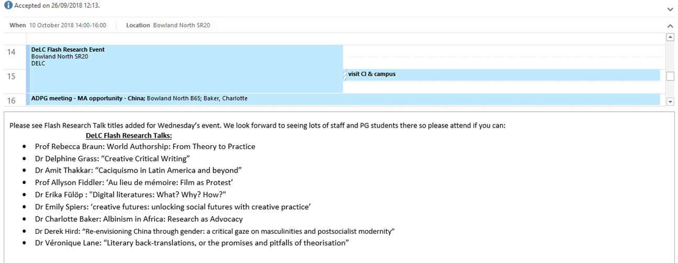

To insert a landscape page, please copy from the first red marker down to here and paste into the document where the landscape page is required.
Figure 29: DeLC staff tweets (8/2/2019)
DeLC’s HoD and two Professors (all female) tweet regularly:
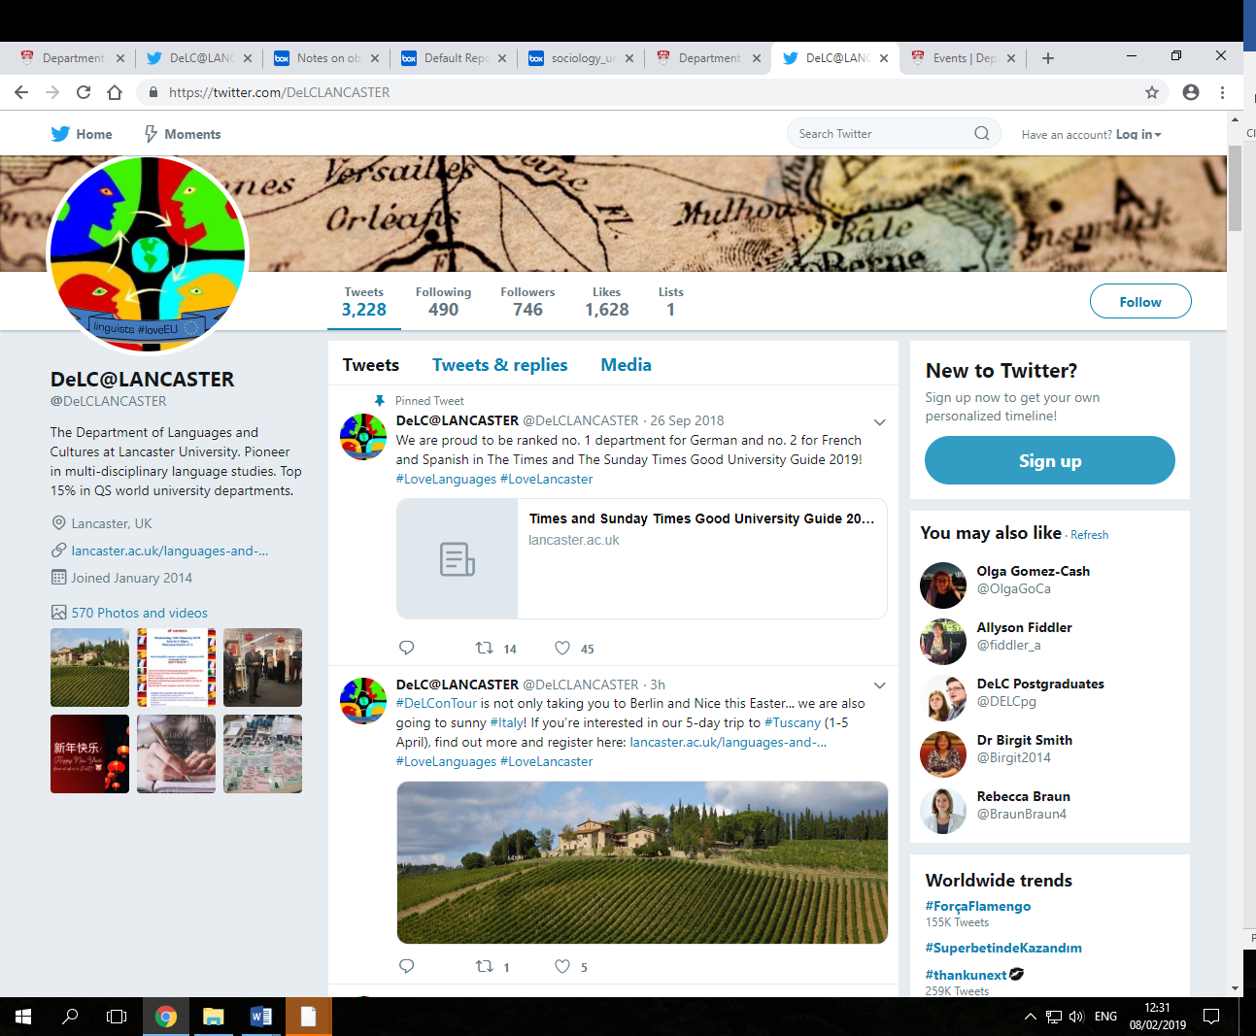
Female academics have high profiles in the DeLC news pages.

Figure 30: DeLC news pages (8/2/2019)
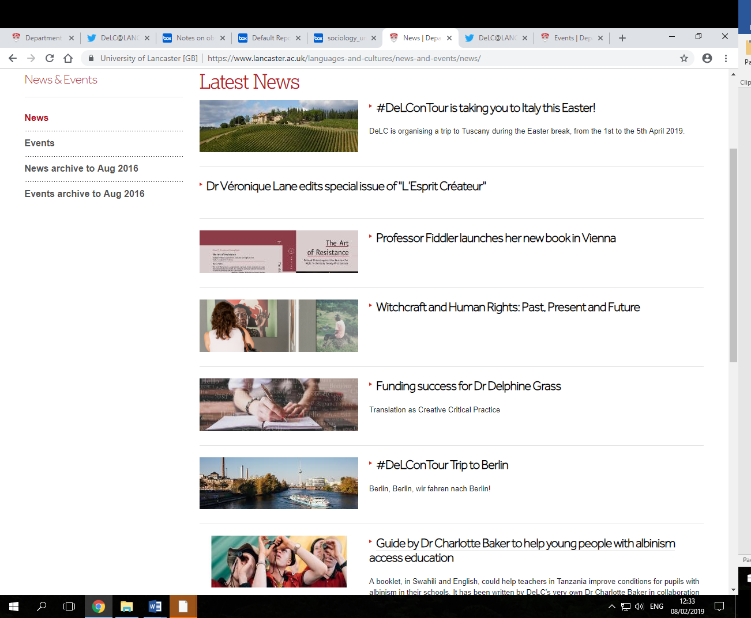

Outreach activities
The external engagement strategy is key at Lancaster, exemplified by a recent University and 30 other institution commitment to produce a ‘Civic University Agreement’ in partnership with local government and others. ‘Citizenship’ is thoroughly embedded in DeLC culture. Staff contributions are recognised in work allocations and promotion cases. Student participation contributes to the Lancaster Award (an extracurricular honour) and enhances CVs for employment.
DeLC has a flourishing school liaison and community engagement programme. School liaison is led by a male academic-related colleague. Academic-related staff have delivered most school visits in 2018-19 to-date. Academic-related staff, (9 women, 5 men) lead on workshops such as the Translation Event for A-level teachers and community engagement (e.g. Campus in the City). CI staff deliver a Chinese language and culture-focused school and community engagement strategy across the north-west region. DeLC staff engage on outreach with other centres such as the Institute for Social Futures. Table 18 shows DeLC staff numbers and genders involved in outreach.
Table 18: Staff involved in engagement events by gender and role
From January 2018-April 2019 | Women | Men | Type of Staff
24 schools in AY2018-19 | 8 | 23 | HoD, Academic (5), Academic-related (16), Professional (3), PG Student (1), UG Student (6)
Campus in the City 2019 | 3 | 2 | Academic-related (5)
Speaking at Engagement Workshops in 2018 | 6 | 3 | Academic-related (8), Academic (1)
Community Readings/ Talks in 2018 | 1 | 1 | Academic (2)
One staff (2018 survey) expressed the following gender-related workload concerns:
‘I remain concerned that some women tend to take on greater ‘citizenship’ and that this is harder to quantify in promotion.’ (female academic-related)
DeLC will conduct an annual analysis of gender representation across workload, including outreach, to inform decision-making and contribute to a more balanced participation (AP A.8).

2038 words

Actions from this section
Action point number | Action
A2 | Generalise sense of responsibility within DeLC for EDI
F2 | Raise awareness about informal and formal channels for students to report gender-based harassment
F1 | Improve communication between staff and students about gender-related issues in students’ experience
A3 | Review membership of SMT
D1 | Adjust to growth
A8 | Gather information on gender representation across workload
E1 | Revise and relaunch a Department Induction Handbook to sit alongside the revised University Induction portal
C2 | Ensure committee and dept. meetings are not just scheduled but also completed in core hours
A6 | Run workshop on recognising and rewarding citizenship (open to PGs and ECRS as well as part of their career development – understanding the changing landscape of HE)

SILVER APPLICATIONS ONLY

CASE STUDIES: IMPACT ON INDIVIDUALS
Recommended word count: Silver 1000 words
Two individuals working in the department should describe how the department’s activities have benefitted them.
The subject of one of these case studies should be a member of the self-assessment team.
The second case study should be related to someone else in the department. More information on case studies is available in the awards handbook.

7. Further information

Recommended word count: Bronze: 500 words | Silver: 500 words
N/A

8. Action plan
The department has already strengthened actions to address 2018 feedback:
- Equality, Diversity and Inclusivity is now included as a standing agenda item at Departmental Meetings.
- At each departmental meeting, the HoD dedicates one part of the meeting to sharing information with staff on processes involved in running the department, seeking questions and comments. Workload distribution, recruitment processes, budgeting and the financial position of the department are areas that will be addressed in 2019.
Following the 2019 survey results, further actions will be:

To insert a landscape page, please copy from here down to the next red marker and paste into the document where the landscape page is required.

Table 19: Action Plan

Action Number | Section Reference | Action |  | Rationale | Key outputs & milestones | Timeframe | Person responsible | Output to-date | Success criteria & outcome
A. Developing and sustaining a culture of equality, diversity and inclusion
1. | 3 | Generalise sense of responsibility within DeLC for Athena SWAN and enhance visibility |  | Some staff stated in surveys DeLC culture does not exhibit gender equality awareness as it should | 1. Acceptance that all staff will participate in SAT for 2 year service. | 1. Begin. academic year 2019-20, make proposal to dept. meeting | 1. HoD | EDI standing item on dept. meeting agenda | 1. At least 90% satisfaction in survey returns that DeLC’s culture and practices foreground gender equality by 2023.  2. Athena SWAN and gender equality written into all departmental roles by begin. academic year 2020-21.  3. In 2020, aim for 50% staff survey participation increasing to 60% in 2021, 70% in 2022, 80% in 2023.  Aim for 20% student responses in 2020, 30% in 2021, 40% in 2022, 50% in 2023.
 |  |  |  |  | 2. Develop SAT Rota for next three years | 2. Begin. academic year 2019-20 | 2. Current SAT Chairs to draft | EDI officer role and SAT merging
 |  |  |  |  | 3. Include UG and PG student rep. on SAT (paid) and ensure workload allocation or ex gratia payments for PS staff on SAT | 3. Begin. academic year 2019-20 | 3. Current SAT Chairs
 |  |  |  |  | 4. Work with DeLC, LU & FASS EDI officers/committees to make induction plan for new SAT members and update EDI section of dept. website | 4. by Sept. 2019. | 4. Current SAT Chairs to do
 |  |  |  |  | 5. Delivery of Athena SWAN Action Plan written into every Director’s role | 5. Start of academic year 2019-20 | 5. HoD, with SMT
 |  |  |  |  | 6. Increase AS staff survey responses from 45% in 2018 and 38% in 2019 levels.  Increase student survey responses from 7% in 2018 and 12% in 2019. Consider promotional strategy and timing of surveys. | 6. From January 2020, and annually | 6. SAT
2. | 5.6 (i) | Generalise sense of responsibility within DeLC for EDI |  | We need to ensure we keep staff and students together as we match dept. practice to changing EDI objectives | 1. Extend SAT analysis to intersectional issues – e.g. how does our picture/strategy change if we look at ethnicity as well as gender in our student and staff populations? | 1. From beg. academic year 2019-20 | 1. SAT and EDI Officer | SAT chair already circulates EDI opps via dept. email | 1. At least 90% awareness of EDI practice in DeLC/ LU reported on survey returns by 2023  2. 100% confidence that DeLC supports equality, diversity and inclusion in its culture and practice on survey returns by 2023  3. 100% confidence among students that they could make a complaint without fear of ridicule or reprisal by 2023
 |  |  |  |  | 2. Hold an EDI workshop, with particular emphasis on unconscious bias | 2. Summer term 2019 | 2. Chair of AS SAT team
 |  |  |  |  | 3. Keep staff and students up to date on EDI issues/ opportunities via posters around the department; refer staff to relevant pages of HR website during induction also to LGBT and LU Women’s network; DO to send emails to staff who have not completed EDI training every Monday morning until it is done | 3. From summer 2019 | 3. EDI officer/SAT/ DO
3. | 5.6 (iii) | Review membership of SMT |  | There is currently only 1 grade 9 academic-related staff (HoD) to serve on SMT. Academic-related staff represent 58% (14 of 24) of permanent academic staff and a large part of fractional staff. | Include Chair of LangCom on SMT | October 2019 | HoD |  | Inclusion of Academic-Related staff member on SMT by 2020
4. | Section 5.3 | Lobby for better promotion frameworks for Professional Services staff |  | It is hard to progress in job roles in the PS team without either seconding or moving roles | 1. Form a DeLC working group and brainstorm possible proposals | - Summer 2020 | 1.SAT with EDI officer and PS team |  | In the 2022 survey, we aim to have 90% satisfaction that DeLC is working to improve promotional frameworks for PS staff.  Improved promotion frameworks by 2023.
 |  |  |  |  | 2. Contribute to work being done by HR, Faculty & Central staff to enhance Professional Staff promotion | - Ongoing | 2. HoD, SAT and EDI
 |  |  |  |  | 3. Through PDRs, support PS staff to enhance competencies and to consider and prepare for secondments. | 3. By Sept. 2020 | 3.DO, HoD and PDR reviewers
5. | 5.6 (v) | Investigate senior staff perceptions around workload allocation |  | 3 Senior Lecturers feel work is not allocated on a clear and fair basis | Understand why this perception is reported by running focus groups run by an external facilitator | Summer 2019 | HoD and PDR reviewers |  | 100% staff survey report that workload is fairly allocated by 2022
6. | 5.6 (vi) | Run workshop on recognising and rewarding citizenship (open to PGs and ECRS as well as part of their career development – understanding the changing landscape of HE) |  | ‘Citizenship’ is important and growing, as part of engagement agenda | Staff understand that citizenship is counted towards workload and promotion | Summer 2020 | HoD |  | 100% staff survey report that citizenship is fairly recorded and acknowledged by 2020
7. | 4.2 (iii) | Collect data as staff leave, to supplement the data which the Institution will begin to collect and to inform DeLC’s longer term EDI practices |  | To know whether there are gendered reasons for staff departures | 1.Develop an anonymous online DeLC exit questionnaire for staff who leave | By Sept. 2019 | 1.Athena SWAN SAT Chairs |  | A database of qualitative data from staff who leave on their reasons for leaving, beginning with the next departure
 |  |  |  |  | 2. Ask departing staff to complete the questionnaire | Ongoing | 2. HoD
8. | 5.6 (iii) | Gather information on gender representation across workload |  | DeLC aims to have a balanced gender representation | 1. Annual gender analysis of workload allocation | March 2020 | 1. HoD and DO |  | More information for decision-making on gender representation across workload
B. Developing strategies for overcoming gendered pipeline challenges at undergraduate and postgraduate levels
Action Number | Section Reference | Action |  | Rationale | Key outputs & milestones | Timeframe | Person responsible | Output to-date | Success criteria & outcome
1. | 2 and 4.1 | Improve the pipeline for potential male undergraduates interested in studying at DeLC |  | DeLC aims to improve on modern languages sector gender ratio, where women UGs are in majority | 1. Provide more male role models in outreach and engagement events at Secondary school level | 1. From academic year 2019-20 | 1. Knowledge Exchange Officer & Schools Liaison Officer (being careful not to overburden underrepresented staff) | 1. Since 2018, our Schools Liaison Officer is a male academic-related member of staff – this will continue | 1. Rise in applications by male candidates by 10% by 2024  2. Rise in acceptances of offers by male candidates by 10% by 2023
 |  |  |  |  | 2. Highlight male role models at our Open Days and Applicant Visitor Days | 2. from 2019-20 | 2. Recruitment officer
 |  |  |  |  | 3. Run gender neutral recruitment events and follow up with underrepresented candidates; plan tailored recruitment event following Edinburgh Napier University model | 3. Plan for roll out in 2020/1 | 3. HoD, SMT, Outreach/Engagement officer, Recruitment Officer
2. | Section 4.1 | Improve UG-PGR progression pipeline for female applicants |  | Our data shows we have a shortfall of PGR acceptances by women in comparison to UG | 1. Form PG specific working group to explore reasons for leaky pipeline (survey prospective and current students re: factors influencing decisions to continue into PG study, and choosing to continue their studies in DeLC; develop actions in response to these findings) | 1. Begin. Academic year 2019-20 | 1. Postgraduate co-ordinator | New MA in Translation has already begun this work | 1. Attain a ratio of male/female PGRs that is 50%F/50%M by 2023.  Our ratio is currently 45% F to 55% M
 |  |  |  |  | 2. Employ female PGRs as ambassadors in recruitment activities | 2. Implement PGR ambassador programme in 2019-20 cycle | 2. Postgraduate co-ordinator
 |  |  |  |  | 3. Staff to identify female UG students to discuss PG options | 3. Lent term every year | 3. PG Director/MA in Translation Director
3. | 4.1 | Improve degree attainment at ug and PGT level for male students and monitor degree attainment for women at PGR |  | Since 2015 M 1sts have decreased while M 2:2s have increased; the inverse pattern is discernible for women; men are less likely to achieve distinction at PGT; degree completion at PGR for women requires monitoring | 1. Understand the reasons why degree attainment issues exist by forming a working group with SAT/EDI and student-staff committee  2. Run an intersectional analysis of men at UG, PGT and women at PGR to understand other potential factors contributing to attainment issues | 1. Begin. academic year 2019-20  2. Begin. Academic year 2019-20 | Director of UG Studies/Director of PG studies |  | A four-year plan to improve degree attainment in male UGs and PGT: By 2023 increase M 1sts from 0% to 20%); in PGT increase Distinctions by 33% to 43%; establish monitoring system for female attainment at PGR
C. Improving support for flexible and part-time working and managing career breaks
Action Number | Section Reference | Action |  | Rationale | Key outputs & milestones | Timeframe | Person responsible | Output to-date | Success criteria & outcome
1. | 5.5 (iii) | Improve the support for those preparing for maternity/adoption or paternity leave and returning to work after |  | Of the two cases of maternity and adoption leave over the last 5 years, both had concerns about support provided | 1. Introduce phased return for maternity /paternity/adoption leave (to grow research before teaching starts) | 1. 2020 | HoD |  | A four-year plan designed to yield an upward trend of annual increases in satisfaction re: communication re: maternity/paternity/adoption leave from 67% towards 100% by 2023; ensure that the next colleague eligible for MARS submits a request (or expresses a clear reason why this is not desirable) (ongoing); submission of a DeLC request for FASS to explore breast-feeding facilities by the end of 2019/20.
 |  |  |  |  | 2. Lobby the central administration for breastfeeding locations on campus | 2. Active, 4 year plan | 2. EDI and SAT
 |  |  |  |  | 3. Monthly check-in meeting with line manager during pregnancy and on return to work to check preparations and support are in place and to discuss applicable policies | 3. Sept. 2019 | 3. Line managers
 |  |  |  |  | 4. Discuss and plan for Keeping in Touch days before going on leave | 4. Now active, and ongoing | 4. HoD and DO | Already in place (since 2018)
 |  |  |  |  | 5. As soon as leave is confirmed, inform research active staff of MARS | 5. Now active, and ongoing | 5. HoD and DO | Already in place (since 2018)
 |  |  |  |  | 6. Ask staff if they wish departmental emails to be sent to their personal emails rather than have to logon to work email. | 6. Now active, and ongoing | 6. DO | Already in place since 2018
 |  |  |  |  | 7. Create & display posters summarising policies in the department | 7. From May 2019, ongoing | 7. AS SAT
 |  |  |  |  | 8. Discuss with HR ways to connect returning staff to mentors with similar experience. | 8. From May 2019 | 8. EDI and SAT
2. | Section 5.6 (vi) | Ensure committee and dept meetings are not just scheduled but also completed in core hours |  | This was a comment that came through in the staff survey | Start meetings at 1.pm instead of 2.pm | 1.Ongoing | HoD and all staff who will prepare for Dept. Meetings, plus staff who will give shorter verbal reports | Reports already shared before the meeting to shorten verbal reports. | 100% of dept. meetings concluding in core hours from 2019-20
3. | Section 4.2 (vi) and 5.5 (vi) | Consider how to enhance value felt by part-time and fractional staff |  | Part-time staff form a large part of DeLC’s staff. It is important that they wish to contribute and feel part of the team. | 1. SAT team / EDI will organise an externally facilitated focus group in order to drill down into the experiences of staff on various types of contracts (eg fractional, part time ftc) and formalise strategy to combat any sense of disenfranchisement | 1.Sept. 2019 | 1. EDI Officer/SAT | Part-time staff are already invited to all events, and are on LU and DeLC mailing lists. Impending move to new office space will bring a staff room, which will help general staff integration | 100% respondents to staff survey consider part-time staff to be equally valued and fully integrated into the dept. by 2023
 |  |  |  |  | 2. Consult with other dept. to see how they manage this | 2. Sept. 2019. | HoD
4. | Sections 5.5 (i), (ii), (iii), (iv), (v) and (vi) | Improve awareness of University policies on flexible working |  | Staff who had taken maternity leave felt we could better communicate policies | 1. Review the department’s communication plan to check we improve communications re. maternity/  adoption/  shared parental leave policies and flexible working with regard to  i) what we communicate  ii) how we communicate | 1. i. January 2020.  1.ii. August 2020. | EDI Officer/SAT | Shared parental leave posters are on display, others will be created and displayed | 100% staff aware of policies by Dec 2020.
D. Find long-term solutions for departmental growth and reliance on fixed-term, fractional posts
Action Number | Section Reference | Action |  | Rationale | Key outputs & milestones | Timeframe | Person responsible | Output to-date | Success criteria & outcome
1. | 5.6 (i) | Adjust to growth |  | Reduce the number of Associate Lecturers employed on fixed-term, part-time contracts | Lobby Faculty for the need for new dept. post, and work with HR about improving employment practices in DeLC | 1. Ongoing from 2019-20 | SMT, HoD and HR |  | Acquire one new academic post for 2021-22 or, at least, establish full clarity from Faculty on expected staff FTE growth in the period of this Action Plan.
E. Improving awareness and ensuring best practice in recruitment, promotion and training
Action Number | Section Reference | Action |  | Rationale | Key outputs & milestones | Timeframe | Person responsible | Output to-date | Success criteria & outcome
1. | Section 5.1 (ii) | Revise and relaunch a Department Induction Handbook to sit alongside the revised University Induction portal |  | Survey showed that more work needed to be done to ensure awareness amongst staff of the practices like recruitment and promotion | 1. Over the course of summer 2019 and summer 2020 and 2021, sections of the handbook will be produced and shared on a new Moodle page | Summer 2020/1 | SMT, HoD, DO | The current Handbook is available on staff shared drive, but this is not very user-friendly | Improved awareness in the staff survey – all staff (100%) aware of promotion criteria and process by 2021
2. | Section 5.1 (i) | Ensuring best practice and transparency in recruitment processes |  | Data from the surveys showed staff had little idea whether recruitment processes were carried out fairly and without gender bias | 1. All staff on Senior Management Team to undertake recruitment training as a matter of course  2.  Provide Staff Development Session on the University’s new ‘Recruitment Toolkit’ to improve awareness of recruitment process  3. Yearly report to Departmental Meeting about recruitment policy and practice  3. Ensure the new Recruitment Toolkit used for new appointments including the new software tool check on adverts to avoid any gender bias – relevant staff familiarise themselves with this | 1. From 2020 ongoing  2. Summer 2020  3. Every May  3. From May 2019 | SMT, HoD  HoD  DO | Software tool already used for latest appointment in Spanish | Improved awareness in the staff survey – all staff (100%) aware of recruitment process by 2021
3. | Section 5.1 (iii) | Improve awareness of promotion criteria/processes |  | Some staff not aware of the promotion process for their role | 1. Include promotion timelines/criteria in the Induction toolkit  2. Posters around dept. | 1. Next academic year (2019-20)  2.2019/20 | EDI/SAT with DO and HoD and Staff Development Officer | The HoD or other PDR reviewer already works with an 18-month plan for people being promoted | 100% awareness of promotion processes in 2021 staff survey
4. | Section 5.3 (i) | Design a new system for monitoring training needs for all staff, which includes post-training evaluation of effectiveness. |  | 3 (21%) out of 14 respondents in 2019 felt they were unable to access training that was relevant to their career development needs | 1. DO to collect training needs identified in PDRs to produce a yearly staff development action plan; also to communicate with HR OED centre to arrange for bespoke training if not currently offered. | Start at the next round of PDRS summer-Sep 2019 | DO to collate and HoD to run |  | Decrease number of respondents in 2021 survey who feel unable to access training they need to max. of 5%
F. Improving student experience of gender equality – improving staff-student communication
Action Number | Section Reference | Action |  | Rationale | Key outputs & milestones | Timeframe | Person responsible | Output to-date | Success criteria & outcome
1. | Section 5.3 (iv) | Improve communication between staff and students about gender-related issues in students’ experience |  | In the 2019 survey, 5 (22%) out of 23 students felt that gender inequality did affect their ability to progress throughout their degree | 1. Include staff EDI Officer and SAT member at every staff-student committee meeting (termly) to table discussion about gender-related issues arising | 1. Every term ongoing | Staff EDI Officer/SAT member |  | 1. 100% confidence among students by 2021 that they could make a complaint without fear of ridicule or reprisal  2. Minimise the percentage of students who feel gender plays a role in their academic progression with an aspiration of 100% success and an expected success rate of at least 90%  by 2021
 |  |  |  |  | 2. Improve general communications between staff EDI rep and students; regular email contact; posters in the resource centre; attendance at freshers events | 2. Every year and ongoing
2. | Section 5.6 (i) | Raise awareness about informal and formal channels for students to report gender-based harassment |  | 18 (78%) out of 23 student respondents to the 2019 survey said they would not know where to go to make a formal or informal complaint if they did at any point feel they had experienced gender-based harassment | 1. Add section to student handbooks on the DeLC web office with information about university services (The Base – student services) | 1. By summer 2019 | 1. EDI rep and the DO officer is responsible for checking that this has been done. |  | Minimise the number of students who are unaware of where to go in the event of gender-based harassment with an aspiration of 100% success by 2020.
G. Improving support and transparency around research
Action Number | Section Reference | Action |  | Rationale | Key outputs & milestones | Timeframe | Person responsible | Output to-date | Success criteria & outcome
1. | Section 5.1 (iv) | Improve transparency of REF process to ensure colleagues are reassured re: gender equality of process |  | 7 out of 13 respondents to the 18-19 staff survey were unsure of whether the process was being undertaken in a gender equal manner | 1. Statement about DeLC’s ethos and practices re. REF to be included in new Departmental Induction Handbook; Involve all research staff in drafting statement  2. Director of Research will provide a detailed report about our own REF processes at the next departmental meeting | 2019-20  Year beginning 2019-20 | Director of Research | All staff are set to be returned for REF 2020/1 | Improved awareness shown in staff survey – at least 90% of respondents confident of gender equal manner of REF process
2. | Section 5.3 (v) Support with research grants | Provide support to research staff following unsuccessful bids to support them to developing bids in new ways |  | To grow the research base of the department | All unsuccessful bids followed up with a 1:1 | 2019-20 | Director of Research | 1:1s already happening in prep for grant submission | To strengthen the research environment with special attention to grant capture from external sources and at least 1 unsuccessful bid resubmitted to another research council by 2021

To insert a landscape page, please copy from the first red marker down to here and paste into the document where the landscape page is required.

This guide was published in May 2015. ©Equality Challenge Unit May 2015.
Athena SWAN is a community trademark registered to Equality Challenge Unit: 011132057.
Information contained in this publication is for the use of Athena SWAN Charter member institutions only. Use of this publication and its contents for any other purpose, including copying information in whole or in part, is prohibited. Alternative formats are available: pubs@ecu.ac.uk

To insert a landscape page, please copy from here down to the next red marker and paste into the document where the landscape page is required.

Landscape page
If you require a landscape page elsewhere in this document, please turn on SHOW/HIDE and follow the instructions in red. This text will not print and is only visible while SHOW/HIDE is on. Please do not insert a new page or a page break as this will mean page numbers will not format correctly.

To insert a landscape page, please copy from the first red marker down to here and paste into the document where the landscape page is required.

LANGUAGE TRENDS 2016/17LANGUAGE TEACHING IN PRIMARY AND SECONDARY SCHOOLS IN ENGLAND. SURVEY REPORT by Teresa Tinsley and Kathryn Board, commissioned by the British Council, p.17 and p.21.
LU’s figures are an average taken from monthly data snapshots, which is why the percentages don’t always match the raw numbers.
N.B. 1. Grade P roles cover academic-related and professional services staff. Grade A roles cover academic staff.
The terms and conditions for all fractional contracts are the same as all indefinite, full-term contracts (they are simply pro rata). For part-time, teaching-only Associate Lecturers (ALs), hours and days of teaching are arranged by engagement contract; paid annual leave entitlement is calculated by reference to a notional full time annual holiday entitlement of 28 days per annum inclusive of bank and public holidays; subject to age and earnings level, ALs may be eligible for auto-enrolment into one of the University’s occupational pension schemes; there is no entitlement to the University's sick pay scheme; and the agreement may be terminated by either party giving written notice of at least one week.
LANGUAGE TRENDS 2016/17LANGUAGE TEACHING IN PRIMARY AND SECONDARY SCHOOLS IN ENGLAND. SURVEY REPORT by Teresa Tinsley and Kathryn Board, commissioned by the British Council, p.17.
JOINT COUNCIL FOR QUALIFICATIONS - Provisional GCE A Level Results - June 2018 (All UK Candidates), n.p.
HESA statistics for Modern Languages 2017-18.
Christine Pollock & Laurie Anne Campbell, ‘Sharing learning from our attracting diversity project’, Advance HE blog, 24/05/2017 [accessed 2/4/2019].

